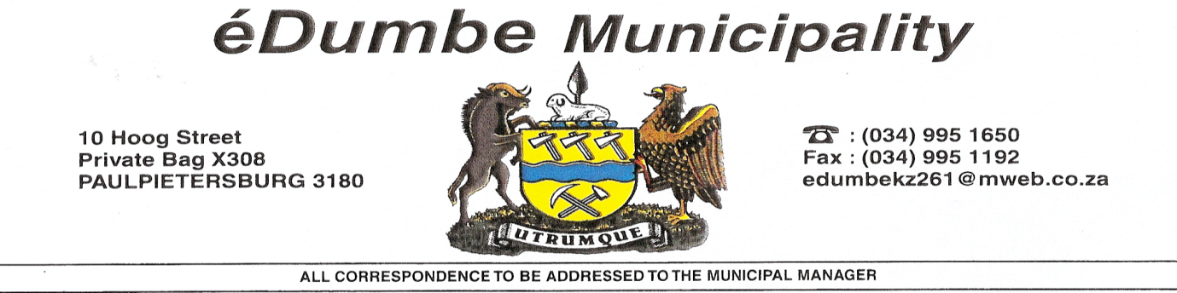

Ref: Date 31 August 2017

Enquires: S Mngwengwe email: [mngwengwes@edumbe.gov.za](mailto:mngwengwes@edumbe.gov.za)

MUNICIPAL NOTICE: SCM 01/2017/18

**INTENTION TO AWARD TENDERS**

The eDumbe Local Municipality hereby gives notice that it intends to award the following tenders in terms of its Supply Chain Management Processes.

|  |  |  |
| --- | --- | --- |
| **NAME OF THE SUPPLIER** | **BID NUMBER AND DESCRIPTION** | **AMOUNT** |
|  |  |  |
| **VEZOKUNGCONO YIMPIE JV** | **CONSTRUCTION IMPUCUKO SPORTSFIELD** | **R 2,558787.00** |
| **DLABANDLONDLO-DEEZLO JV** | **FENCING OF EDUMBE CEMETERY** | **R1,736428.50** |
| **ETHALA CONSTRUCTION** | **CONSTRUCTION OF THOLAKELE ACCESS ROAD** | **R1,537768.91** |
| **MELA OKUHLE TRADING** | **CONSTRUCTION OF KANYE KANYE HALL** | **R2,570885.44** |
| **SMM TRADING AND PROJECTS (PTY) LTD** | **OPHUZANE COMBI COURT** | **R1,728181.29** |
| **KHANYISA CIVILS & GENERAL MAINTENANCE** | **EZINGUDENI PEDESTRIAN BRIDGE** | **R2,697686.31** |

I am optimistic that you will find the above in order

Yours faithfully,

**Mr TV Mkhize**

**Municipal Manager**

**Edumbe Local Municipality**