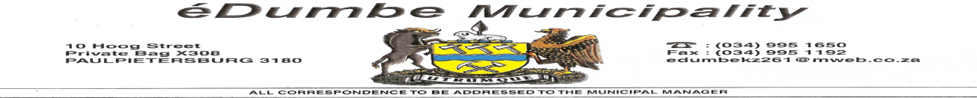

éDumbe Municipality hereby invites experienced and suitably qualified service providers to bid.

Contract number | PROJECT NAME/Description | Tender Doc fee
EDUMPRO 09/2017/18 | ELECTRICAL ENGINEERING SERVICES (Panel of contractors for 3 years) | N/A
EDUMPRO 10/2017/18 | MECHANICAL ENGINEERING SERVICES (Panel of contractors for 3 years) | N/A
EDUMPRO 11/2017/18 | CIVIL ENGINEERING SERVICES (Panel of contractors for 3 years) | N/A
EDUMPRO 12/2017/18 | CHANGING OF TYRES (Panel of contractors for 3 years) | N/A
EDUMPRO 13/2017/18 | SERVICE PROVIDER THAT WILL DEAL WITH MEDIA (One service provider for 3 years) | N/A
EDUMPRO 14/2017/18 | SERVICE PROVIDER TO SOURCE OF FUNDING AT OWN RISK | N/A
EDUMPRO 08/2017/18 | BUILDING FOR SPORTS AND RECREATION PROJECTS MANAGEMENT | N/A
EDUMT 09/2017/18 | SUPPLY AND DELIVERY OF EPWP PROTECTIVE CLOTHING & TOOLS | R 256.20
EDUMT 10/2017/18 | SUPPLY 2 BRAND NEW 21 CUBE REFUSE COMPACTOR TRUCK AND TRAILERS | R640.50
EDUMPRO 15/2017/18 | VOIP PBX & HANDSET RENTAL- PURCHASE FOR 3 YEARS | N/A

Bidders need to complete and attach Terms of reference to their proposals and tender documents for protective clothing which will be available to the municipality and TOR on request from buthelezibw@edumbe.gov.za as from 06 March 2018. The evaluation criteria will be contained on the "Terms of Reference" which will be obtained from the municipality. The evaluation of bids will consider functionality and PPPFA. The closing date will be 14 March 2018, at 12H00 in eDumbe Municipality, where after, bids will be opened in public.
Bidders must meet eligibility criteria / requirements in their submission to be considered. Bidders must have a relevant track records and registered with relevant council. Prospective bidders must be registered on both Central Suppliers Database and eDumbe Municipality Suppliers database. The eDumbe Municipality does not bind itself to accept the lowest and reserves the right not to accept the whole or part of the bid
Written bids or proposals are to be submitted in a sealed envelope clearly marked, " the relevant project. description and the bid number".
Technical enquires should be directed to Mr.MS Khanyile / Mr. M Madi : Technical Services, Mr. CK Mncwabe ICT at 034 995 1873. Further information may be obtained from Mr. BM Ntombela, SCM Manager at 034 995 1650.

TENDER CLOSING DATE: 14 March 2018 CLOSING TIME: 12H00

_________________________
MUNICIPAL MANAGER

