
ÉDUMBE Municipality
section 72 mid-term performance report
2018/2019 financial year

CONTENT

Chapter 1: Legislative Mandate
Overview
Chapter 2: Governance
- Administrative Governance
- Political Governance
Chapter 3: Organisational Performance Quarter 1
- Municipal Transformation
- Basic Service Delivery and Infrastructure Development
- Financial Management
- Local Economic Development
- Planning and Development

MESSAGE BY THE ACCOUNTING OFFICER
As the Accounting Officer of eDumbe Municipality, I am taking this opportunity again to express my sincere gratitude thanks to His Worship Hon. S.J.Kunene, Executive Committee Members and the whole Council for trusting me and my management team with the responsibility of being the agency of change in this municipality. Since we started with our responsibilities as Municipal management team, we have committed ourselves in working as one team with one vision and mission.

In terms of Section 46 of the Municipal Systems Act, 32 of 2000, municipalities are required to prepare an Annual Performance Report that forms part of the Annual Report to be prepared in terms of the Municipal Finance Management Act, 56 of 2003. This Performance Report is based on organisational objectives and the progress made by eDumbe Local Municipality.

It also gives an indication of expected targets in the Service Delivery and Budget Implementation Plan that was approved by Council for 2017/2018 financial year. This is in a form of a template that was prepared to monitor performance at an operational level.

Cogta defines PMS as “a strategic approach to management which equips leaders, managers, employees and stakeholders at different levels, with a set of tools and techniques to regularly plan, continuously monitor and periodically measure and review performance of the organisation (municipality) in terms of indicators and targets for efficiency, effectiveness and impact”.

Performance Management System is also intended to assist Council to improve service delivery by channelling its resources to meet performance targets and in doing so, ensures that the municipality achieves its strategic objectives as contained in its IDP. Service delivery excellence has its firm basis on providing the optimum services to the community of eDumbe and its periphery.

This Annual Performance Report comes at the end of many facets of reporting that I as the Acting Accounting Officer undertook to comply with monthly, quarterly and now annually. In this regard in order to understand the gist of what were undertaken, reportable matters, the timelines, and the general framework. I hereby, refer a reader hereof to the Organisational Performance Management System that is reviewed and approved by Council on an annual basis. This document reads better in conjunction with the Integrated Development Plan for the same period. The essence of this linkage is simple;
- Firstly the Community through visits to wards that happened for the year under review leading to the strategic document or the Integrated Development Plan, which contains the aspirations, projects and programmes thereof, was approved by Council.
- Secondly Council approved the budget that funds certain programmes that are contained in the IDP, and
- Thirdly Council approved the Organisational Performance Management System

The Organisational Performance Management System then regulates that there shall be individual contracts between the Mayor and the Municipal Manager and between the Municipal Manager and the Heads of Departments. Furthermore once these Performance Agreements are in place for the financial year, the Performance Plans are concurrently concluded. The above process is in keeping with Chapter 6 of the MSA, Act No. 32 of 2000, as amended (Act No. 7 of 2011 applies strictly herein). Furthermore, the procedure outlined in the Municipal Performance Planning Regulations applies in formulating objectives and key performance indicators.

The above picture would be incomplete if one omits the Service Delivery and Budget Implementation Plan also approved by the Mayor for this period. This SDBIP is in compliance with Circular No. 13 promulgated on 31 January 2005 in terms of the MFMA, Act No. 56 of 2003. This SDBIP is also concluded between the Mayor and the Municipal Manager and between the Municipal Manager and Heads of Departments. The defining difference between the above plan and the latter is that in the latter divides work into quarterly projections. The assessments that also underpin the appraisal of performance as espoused in legislation is carried out in terms of the Local Government Municipal Performance Regulations of 2006, in terms of which assessments in regards to the first and the third quarters are normally verbal, unless there is underperformance that needs to be recorded for correction, while the second and the fourth are formal in every respect. The process outlining the fourth quarter is as follows:
The formal reports with supporting documents are appraised internally
- Thereafter appraisal takes place by the Audit Committee
- However, the most important regulated mechanism to evaluate performance of the Municipal Manager and Managers accountable to the Municipal Manager normally used is found in Regulation 27(4) (d) of the 2006 Regulations

I conclude by pointing out that I deliberately avoided context hereof as I am a subject of assessment and appraisal. However, the outcome of the assessments will be captured in keeping with Sec 121 of the MFMA in the final Annual Report.

Le me take this opportunity to thank all staff members, strategic personnel and all my management for once again giving it their best performance for the success of the municipality

MP KHATHIDE
ACCOUNTING OFFICER

- BACKGROUND TO MUNICIPAL PERFORMANCE REPORTING
The Mid-Term Performance Report is compiled in terms of the legislative requirements, Chapter 6 of the Municipal Systems Act, 32 of 2000 and Chapter 12 of the Municipal Finance Management Act, 56 of 2003. The Municipal Systems Act prescribes the role of each sphere of government in the municipal performance reporting.

Purpose of the Report
The main purpose of this report is to account to MEC for Local Government, Provincial legislature, NCOP, Minister of Cooperative Governance and Traditional Affairs, National Treasury, Auditor-General and to the citizens of South Africa on progress being made by municipalities towards achieving the mid-term goals of “a better life for all”. Furthermore, the report is a key performance report to the communities and other stakeholders in keeping with the principles of transparency and accountability of government to the citizens. It subscribes to the South African developmental nature of participatory democracy and cooperative governance and responds to the principles of the Constitution, Batho Pele, White Paper on Local Government, MSA and the MFMA

The Assessment Process and the Methodology followed in Compiling the Report
According to the provisions of the Municipal Systems Act, 32 of 2000, municipalities must monitor and measure the progress of their performance by preparing quarterly and mid-year performance reports, in terms of Chapter 6 of the MSA, on performance management systems. These quarterly and mid-year reports make up the municipalities’ annual performance reports (Section 46 report), which are submitted to the Auditor-General, together with the financial statements, for auditing. After adoption of the audited performance report by the municipal council, it must then be submitted to the MEC for Local Government.

Compilation and Structure of the Report
The report should present the status of current progress on mid-term performance which has been conducted. This is followed by a brief assessment attached as Annexure 1 showing the outcome on the Performance of each Key Performance Indicator (KPI), POE, Comments and Corrective Measures on KPI’s not Achieved.

THE MUNICIPAL REPORTING PROCESS
SECTION 72 OF THE MUNICIPAL FINANCE MANAGEMENT ACT, 56 OF 2003
SECTION 46
- of the Municipal Systems Act (MSA) 32 of 2000, states that (1) a municipality must prepare for each financial year a performance report reflecting: the performance of the municipality and of each external Service provider during that financial year; also a comparison of the performances referred to paragraph (a) with targets set for and performances in the previous financial year; and measures taken to improve performance.

(2) The Mid-Term Performance report must form part of the municipality’s annual report in terms of chapter 12 of the Municipal Finance Management Act

SECTION 121 OF THE MUNICIPAL FINANCE MANAGEMENT ACT (MFMA) 56 OF 2003, REQUIRES THAT:
(1) Every municipality and every entity must for each financial year prepare an annual report. The Council of a municipality must within nine months after the end of a financial year deal with the annual report of the municipality and of any municipal entity under the municipality’s sole or shared control in accordance with section 129.

- OVERVIEW

A Municipality’s Performance Management System is the primary mechanism to monitor, review and to improve the implementation of the Municipal IDP, and to measure the progress made in achieving the objectives set out in the IDP. The system provides early warning on poor or non service delivery and facilitate decision-making.
The Municipality should set out indicators and targets to compile a Municipal scorecard. Indicators are then cascaded into Departmental SDBIP’s and are to be set on a SMART principle as follows:
- Specific
- Measurable
- Achievable
- Relevant, and
- Time bound

The Key Performance Areas as appear and reported on eDumbe Municipal Scorecard and SDBIP are as follows:
Basic Service Delivery
Municipal Financial Viability and Management
Good Governance and Public Participation
Local Economic Development
Municipal Institutional Development and Transformation

Timeous and regular reporting of performance by Departments on the above KPA’s is then crucial. It also allows for better preparation for audit. Section 56 Manager’s performance are evaluated based on these KPA’s and will be weighted in two components, KPA – 80% and Competencies – 20%.( a set of expectations on good management practise).

- Administrative Governance

The main focus in this key performance area is the institutional and organizational capacity of municipality to perform their functions and fulfill their developmental role as stipulated in the Constitution and the White Paper on Local Government. Institutional and organizational reform in local government is the key to sustainable municipalities. Having been allocated separate powers and functions entrenched in the Constitution; municipalities had to organize themselves in preparation to fulfill these functions and powers. Organizational transformation in local government is further explicitly prescribed in Section 51 of the Municipal Systems Act which provides as follows:
A municipality must, within its administrative and financial capacity, establish and organise its administration in a manner that would enable the municipality to:-
- be responsive to the needs of the local community;
- facilitate a culture of public service and accountability amongst its staff;
- ensure that its political structures, political office bearers and managers and other staff members align their roles and responsibilities with the priorities and objectives set out in the municipality’s integrated development plan;
- establish clear relationships, and facilitate co-operation, co-ordination and communication, between-
  - its political structures, political office bearers, its administration and the local community
  - its political structures, political office bearers and administration and the local community;
- organise its political structures, political office bearers and administration in a flexible way in order to respond to changing priorities and circumstances;
- perform its functions—
  - through operationally effective and appropriate administrative units and mechanisms, including departments and other functional or business units; and
  - when necessary, on a decentralised basis;
  - assign clear responsibilities for the management and co-ordination of these administrative units and mechanisms;
  - hold the municipal manager accountable for the overall performance of the administration;
  - maximise efficiency of communication and decision-making within the administration;
  - delegate responsibility to the most effective level within the administration;
  - involve staff in management decisions as far as is practicable; and
  - provide an equitable, fair, open and non-discriminatory working environment

This key performance area focuses on organizational capacity and includes indicators that show progress on how the municipality has organized itself in terms of building capacity to deliver, compliance with equity targets as well as implementing both the organizational and individual performance management systems. Municipal performance in this KPA is assessed in the following six (6) focus areas:
- Performance Management Systems.
- Filling of Section 57 Manager positions;
- Signed performance agreements by Section 57 Managers;
- Disciplinary processes against Section 57 Managers;
- Employment Equity; and
- Skills development.
During Quarter 1 and 2 (half year of 2018/2019), the Municipal Manager and the Managers that are directly accountable to the Municipal Managers have signed the performance agreements, employment contracts and were forwarded to COGTA before the due date.
.
eDumbe  Municipality | MID-YEAR
eDumbe  Municipality | No of posts approved | No of posts filled | No of vacancies
Municipal Manager | 1 | 1 | 0
Chief Financial Officer | 1 | 1 | 0
Infrastructure & Planning | 1 | 1 | 0
Corporate & Community Services | 1 | 1 | 0
TOTAL | 4 | 4 | 0

- POLITICAL GOVERNANCE
Council Committees are fully functional and effective in performing their delegated tasks.

- ORGANISATIONAL PERFORMANCE
The MSA section 17 (2): requires a municipality to establish and organise its administration to facilitate a culture of accountability amongst its staff. Section 16 (1): states that a municipality must develop a system of municipal governance that compliments formal representative governance with a system of participatory governance. Section 18 (a) - (d): requires a municipality to supply its community with information concerning municipal governance, management and development

- SUMMARY OF MUNICIPAL PERFORMANCE OVER MID-TERM 2018/2019 (JULY – DECEMBER)
The information provided on the table below indicates the overall performance of the Municipality during Mid-term, 2018/2019 financial year. The analysis on targets were performed in line with the 6 national KPAs as regulated in the Municipal Systems
Table 1
Total number of targets | 101
Total number of Mid-Year planned targets | 68
Total number of Mid-Year achieved targets | 51
Total number of Mid-Year non achieved targets | 17
% of Achieved Targets | 75%
% of Non- Achieved Targets | 25%

A detailed report on each target indicating the status of achievement is listed on Annexure A of the report, which gives analysis to the Organisational SDBIP

  - MUNICIPAL TRANSFORMATION AND INSTITUTIONAL DEVELOPMENT, GOOD GOVERNANCE AND PUBLIC PARTICIPATION

The above KPA’s focuses more on the following sections:
A. Information Technology Services;
B. Library Services;
C. Community Services
D. Administrative Services and
E. Human Resource Management (People Management) Services
A: INFORMATION TECHNOLOGY

1. Introduction
The Public Service Corporate Governance of Information and Communication Technology Policy Framework (2012) stipulate that COBIT (Control Objectives for Information and Related Technologies) should be adapted and implemented as the Governance of ICT Framework on the Governance of ICT layer.
COBIT will enable the municipality to achieve their strategic goals by deriving optimal value from ICT through the realisation of benefits and optimising resources and risk.
2. Background
As a set of Governance of ICT and management processes, COBIT will provide Managers, ICT users and Auditors with the following:
- Standard indicators;
- Processes for implementing the Governance of ICT;
- Good practice to maximise the corporate value in using ICT.
- Identification of the accountability and responsibilities of business and ICT process owners.
3. Internet Usage
About more than 60 users who are connected to the municipal Internet. Processing speed of the Internet is 4MB/ps in the main building. When Telkom exchange experiences problem our internet usage also gets affected because connectivity is through ADSL line. There are also remote sites which are at Infrastructure and Maintenance, Planning and Development, Traffic that also supplied with the Internet which also get disrupted in case Telkom is affected.
At Bilanyoni offices there is no Internet due to lack of network coverage in the area. But Telkom promised to attend to the matter.
4. Reviews conducted
As per clause 6.10 of the User Account Management policy reviews are conducted on a monthly or quarterly basis. ICT systems for which reviews conducted are Pastel, Sage VIP, Syntell and Network controller server. The PoEs for the reviews conducted are submitted to the director signing off and compilation of a monthly report to PMS Manager.
5. Disaster Recovery Plan
The ICT unit is implementing the physical backing up of information on a weekly and monthly basis and restores on a quarterly basis as per clause 4 of Backup and Restore policy. Should the disaster occur, for the equipment required the municipality would consider contacting the service providers to supply with the resources to ensure the continuity of the business in an alternative site. Nevertheless, though the financial situation of the municipality is unfavourable but it works so hard to try and accommodate from its budget for 2018/2019 the purchasing of the required equipment.
6. Backups performed

The ICT unit is implementing the backing up of information on a weekly and monthly basis and restores on a quarterly basis as per clause 4 of Backup and Restore policy. It must be noted that the online backup of information is also performed on a daily basis should any disaster or disruption of the systems occur.
7. ICT Contracts
ICT contracts
- Biztec technologies – copier machines | Contract expired in October 2018. SCM process will be initiated for new appointment.
- OTSG – Website | Contract expired in August 2018. SCM process will be initiated for new appointment.
- Mweb – Internet | Contract expired in November 2017 but a month to month contract was arranged. SCM process will be initiated for new appointment.
- Syntell – Electricity (Finance) | Contract expired in November 2012 and a month to month contract until December 2018 was arranged. SCM process will be initiated for new appointment.
- Hexing – Electricity | Contract valid until February 2021.
- PABX s – Telephone system | Contract expired in July 2017. SCM process will be initiated for new appointment.
- CCG Systems – Financial management | Contract expired in August 2017. MEMORANDUM OF AGREEMENT was signed between the municipality and CCG Systems (Camelsa Consulting Group).

- ICT Challenges and Proposals
Challenge | Proposed Solution
- The Internet is slow, but has improved after the minor changes performed on the firewall. | - The current technology (ADSL LINE) needs to be upgraded for better performance. The recommended technology is the Diginet line
- Shortage of working tools and equipment to improve eDumbe municipality’s internal network infrastructure. | - The ICT section should budget and purchase network cables, cabinets, switches, wall mounted boxes, crimper, RJ45, Punch down tool, Network testers, ladder, etc
- Information Security and Cyber-attacks.  The network infrastructure currently in place is inadequate and vulnerable from external and internal attacks (Cyber-attacks and fraud).  The ICT policies in place are in the role of assisting to mitigate the attacks from occurring; unfortunately the fund to purchase the appropriate network infrastructure equipment is the challenge.  There have been 3 incidents reported as cyber-attacks within the municipal buildings. This is an indication that eDumbe Municipality’s network is at a very high risk. | To ensure the data is securely transmitted on the Municipality’s network, the network security infrastructure needs to be upgraded as there is insufficient appropriate equipment to mitigate the attacks from occurring.  - The current network firewall is unlicensed and therefore performs fewer services and applies little effort to secure the network infrastructure from external attacks.  The ICT section should budget and purchase the firewall, The recommended firewall is Check-Point firewall  - The network logs are not performed to monitor the traffic propagated on the network, therefore there is inadequate visibility and a way to identify on the network which device are performing malicious attacks and what traffic is transmitted on the network.  The ICT section should budget and purchase the appliances.  - Implement an encrypted network infrastructure to ensure the data is securely transmitted on the network.  - The ICT section should ensure that the basic network security measures and appliance are implemented on the network. The ICT section should budget and purchase managed network appliances to improve the network security fundamentals (i.e. managed switches and intrusion prevention systems,) and ensure the network appliances propagate the policies throughout the network infrastructure adequately.

- The construction and the appliances of the server room are inadequate. | The ICT unit should budget and purchase the applicable equipment for the server room.  - Purchase the steel door  - Concrete ceiling  - Smoke detector  - Fire suppressor
- DRP/BCP is not tested, therefore in an event of a disaster (i.e. burnt building, floods etc.) the municipality may encounter difficulties responding to the incident as there is inadequate preparation for the event and this could result a delayed business recovery from the event. | The ICT unit should budget and purchase the applicable equipment for the DRP/BCP.  Need funding to purchase all the required equipment
- The municipality is using older software version in addition the products are unlicensed (Microsoft office and windows, network firewall). | The ICT unit should budget and purchase the applicable software licenses.
- Aging and shortage of computers.  For the 2017/18 financial year no laptops and desktop computers were purchased. The budget was available and the procurement processes were attempted to acquire the laptops and computer. Due to the financial constrains the Municipality could not make the purchase.  The employees at the municipality are in possession of laptops and computers with the duration of more than 5 years and the condition of the equipment has depreciated significantly.  There old computers at the stores and the ICT office that can be repaired. | The ICT section should attempt to purchase the parts for repairing the laptops and computers that can be repaired.  ICT section should engage with the HR section; to request that before the departments advertise for new employees they should have the budget of the laptop or computer for the new employee.  The ICT section should attempt to purchase the laptops and computers in the 2018/19 financial year. However, this has been started in quarter 1 but discontinued due to shortage of funds.
- Non-approval of ICT policies  ICT policies were not approved for  2017/2018 financial year by the Council | This is will be declared as finding for 2017/2018 financial
- No appointment of Internet supply service provider | - BEC have to sit for evaluation of tenders.
- No appointment of PABX system supplier | - BEC have to sit for evaluation of tenders.
- No appointment of Copier machines service provider | - BEC have to sit for evaluation of tenders.
- No payment to the supplier for the ICT equipment | - Finance has to process upfront payment for the delivery to occur.
- Information Security and Cyber-attacks.  The network infrastructure currently in place is inadequate and vulnerable from external and internal attacks (Cyber-attacks and Fraud). | - A licensed firewall software has to be purchased.
- About 15 ICT policies reviewed but not approved by Council | - The CCS director must ensure that the remaining ICT policies get approved by the Council at least in the 3rd quarter for implementation in 2018/2019 and beyond.
- No appointment for the construction and installation of the equipment the server room. Requisitions were done in second quarter. | - The appointment of the service provider to supply with the required server room equipment has to be done.
- DRP/BCP test still not implemented. | - Need funding to purchase all the required equipment.
- ICT unit still uses old version King III for implementation of its policies, and this was identified during the audit process of 2017/2018 financial year. | - A provision for ICT staff budget should be made available to attend workshops and training in order them to become conversant with the new technologies.
- No appointment of service provider to supply with 16 laptops advertised | - The BEC sat for evaluation, BAC still have to sit and recommend to the MM for appointment.

- AG Finding 2017/2018
  - Policies not updated

- The IT Strategic Plan has not been updated for the current year and as a result is not in line with the budget for the year and does not fully support the business requirements.
- The ICT Charter has not been updated as it still makes reference to the King III report.
- The IT Strategic Plan does not correspond with the budget for the current financial year.
- The IT Strategic plan may not fully support the business requirements in the current financial year.
- The ICT Governance function is not in line with King IV.

Management response
- All the findings are noted and the accounting officer will ensure to provide with an oversight to the annually review of policies to ensure that they are updated and are in line with the relevant prescripts as recommended. Thereafter, the changes will be communicated to the staff through the training.

  - IT Control Environment

The following deficiencies were identified in the general IT control environment: -
- The function and responsibilities of an IT Governance champion has not been delegated to any staff member.
- The IT steering committee met only two times during the year, contravening the requirement as per the ICT charter i.e. 6 meetings per year.
- The action plan has not been updated for the current year.
- No progress reports are available to track the performance of each vendor based on SLA requirements.
- The standard change request form used for all system updates/upgrades was found it to be inadequate as it does not address the following criteria:
- Impact of the change
- Risk of not implementing the update
- The estimated cost of the update/upgrade and
- Back-out/ rollback procedures
- The Disaster recovery plan test is not being conducted each year.
- Management did not scheduled a disaster recovery test to be conducted as the committee did not provide a budget necessary for the equipment required to implement the annual test.
- Weaknesses or issues that could be identified during testing will not be remedied and the Disaster Recovery Plan will not be updated accordingly.
- A separate IT Risk register is not maintained by the IT department.

Management response
- The ICT Manager was nominated as the IT Governance champion on the 20 February 2018
- The reviewed ICT Charter clause 4.3 bullet No.1 stipulates that the ICT Steering Committee will meet at least four times a year. It should therefore for be an error if it reflects 6 times.
- The IT unit will update the Action Plan every year as recommended
- The IT unit ensures that the service providers or vendors do provide with performance reports such as CCG Systems, Biztec Technologies did. However, it will further ensure that every service provider does generate a report about its performance.
- The standard change request form for all system updates/upgrades will be amended as recommended to include the missing crucial information.
- The ICT unit will of course maintain its own IT Risk register as recommended.

- WEBSITE
Municipal Website: Content and Currency of Material Documents Published on the Municipality Website Yes/No Publishing Date
 | Y/N | Date to be complied | Date Advertised
The annual report (2017/2018) published/to be published (After approval by Council) | Y | To be tabled to Council not later than 31 January 2019 | 19 December 2018

- COMMENT ON MUNICIPAL WEBSITE CONTENT AND ACCESS

ICT Services as a support function within the municipality works with other directorates and departments to ensure that services reach the community through such facilities as community libraries and multi-purpose community halls. Furthermore, access has been increased by ensuring upwards and backwards compatibility of our systems, to ensure that anyone with a device that can process data and that has access to the Internet can open and access our website content. The municipality should monitor and report on the use of its website by the public, for example, by measuring the number of hits on the website.

B. PUBLIC SAFETY
Public Safety is comprised of Vehicles Testing Station, Driver’s License Testing Centre, Registration and licensing of vehicles, Traffic Inspectorate and Disaster Management. During the period under review the following took place:
- Vehicles Testing Station {VTS}
The sub-section deals mainly with Testing of vehicles for Roadworthiness. Furthermore the sub-section had twelve (12) equipment needed to be calibrated which is also inspected by SABS annually. The revenue generated by this sub-section is for municipality. South African Bureau of Standards {SABS} only takes 3% of each vehicle that has been tested. This sub-section is manned by x2 Examiners with Grade A, X1 Pit Assistance x1 General worker, x1 Supervisor and x2 Cashiers

NB: Traffic officer Mr IM Sibiya went through to Traffic Training College and completed his Examiners of Vehicles course. There were hiccups regarding the release of his results due to outstanding payment but eventually results were released.

REVENUE COLLECTED JULY TO SEPTEMBER 2018
ITEM | April – June 2018 | July – September 2018 | +/-Variance | % Increase | % Decrease
COR Application | R 14’000.00 | R26’270.00 | R12’270.00 | 53%
COR Issued | R6’480.00 | R9’320.00 | R2’840.00 | 70%

REVENUE COLLECTED OCTOBER TO DECEMBER 2018
ITEM | July - September 2018 | October – December 2018 | +/-Variance | % Increase | % Decrease
COR APPLICATION | R26’270.00 | R16’930.00 | R9’640.00 | 64%
COR ISSUED | R9’320.00 | R7’200.00 | R2’120.00 | 77%

2. Drivers Licence Testing Centre {DLTC}
The sub-section deals mainly with applications of Driving licence and learners licence, testing and issuing of Learners Licence and Driving Licence, Driving Licences renewals, application and issue Professionals Driving Permits{PrDP}as well as Eye Test. The total revenue generated by this sub-section is for the municipality. This sub-section is manned by 6 employees x2 Examiners with Grade A,X1 Examiner with Grade L,X1 Examiner with Grade F,X1Supervisorand x2 Cashiers.
NB. Senior Traffic officer Ms SF Ngobese also attended Traffic Training course to improve his skills and completed her Driving license course.

REVENUE COLLECTED FROM JULY TO SEPTEMBER
ITEM | April – June 2018 | July – September 2018 | +/-Variance | % Increase | % Decrease
DriversTest | R24’214.00 | R34’079.00 | R9’865.00 | 71%
Learners Test | R20’350.00 | R16’500.00 | R3’850.00 |  | 81%
Leaners Licence Issued | R4’450.00 | R3’440.00 | R1’010.00 |  | 77%
Pprofessional Driving Permits | R25’827.00 | R19’350.00 | R6’477.00 |  | 75%
Driving Licence Cards Issued | R66’177.00 | R51’300.00 | R14’877.00 |  | 78%
Temporary & Duplicates | R12’130.00 | R9’720.00 | R2’410.00 |  | 80%

Item | July – Sept 2018 | October - December 2018 | +/-Variance | % Increase | % Decrease
Drivers Test | R34’079.00 | R25’200.00 | R8’879.00 |  | 74%
Learners Test | R16’500.00 | R18’600.00 | R2’100.00 | 89%
Learners Licence Issued | R3’440.00 | R3’120.00 | R320.00 |  | 91%
Professional Driving Permits | R19’350.00 | R15’150.00 | R4’200.00 |  | 78%
Driving Licence Cards Issued | R51’300.00 | R35’910.00 | R15’390.00 |  | 70%
Temporary & Duplicates | R9’720.00 | R9’540.00 | R180.00 |  | 98%

3. Registration and licensing of vehicles:
The sub-section deals with functions related to vehicles mainly Registration and Licensing. Agency fee calculated at 8.55% of the total revenue is retained by the municipality. This sub-section is manned by 3 employees comprising of x1 Supervisor, x2 Cashiers.

Agency fee calculated at 8.55%

ITEM | April – June 2018 | July-September 2018 | +/-Variance | % Increase | % Decrease
Agency Fee | R65’110.30 | R42’580.05 | R22’530.25 |  | 65%

ITEM | July – September | October – December 2018 | +/-Variance | % Increase | % Decrease
Agency Fee | R42’580.05 | R54’065.35 | R11’485.30 | 79%

4. Traffic
This sub-section deals with all traffic related matters through National Road Traffic Act, Criminal procedure act and Municipal By-Laws. The revenue generated by this sub-section is for the Municipality. It is manned by x1 Traffic Chief Officer, x1 superintendent, x1Senior Traffic officer, x 5 Traffic officers and x1 Traffic clerk.

SECTION 56 NOTICES ISSUED FOR JULY TO SEPTEMBER

Section 56 Notices Issued | Number | Amount
April – June 2018 | 11140 | R744’600.00
July – September 2018 | 936 | R665’400.00

Section 56 Notices Issued | Number | Amount
July - September 2018 | 936 | R665’400.00
October – December 2018 | 614 | R445’700.00

REVENUE COLLECTED ON SECTION 56 NOTICES FOR JULY TO SEPTEMBER

April – June 2018 | July – September 18 | +/- Variance | % increase | % Decrease
R232’000.00 | R73’490 | R158’510.00 |  | 32%

July - September 2018 | October – December 2018 | +/- Variance | % Increase | % Decrease
R73’490 | R94’000.00 | R20’510.00 | 78%

NB: No Section 56 issued to motorist during the month of December due to shortage summons books (Sec 56)

5. ROAD PAINTING
No road painting was done during July to December 2018

6. STAFF TRAINING
Two Traffic officers have completed their courses which started from July to September in Boekenhout Traffic Training College in Pretoria.

7. OVERTIME
No over time worked during the period of July to December 2018

- FIRE
This sub-section deals with fire related functions throughout the whole of eDumbe Area {08 Wards}.It is controlled by the Fire Brigade Act, Standard Municipal By-Laws and Building Regulation SABS 0400-1990.The equipment, to service the community the Fire Team has one old and dilapidated truck SAMAL 50,one old Bakkie and two Bakkie Sakkie and 12 beaters. It is manned of 5 Fire Fighters that do all the functions.

- Disaster Management
These sub-section deals with all issues related to Disaster and it works hand in hand with Fire Sub-section. This sub report all incidents occurred in eDumbe area to Council and District Disaster Management on quarterly basis .It is manned by Acting Disaster officer (Manager Public Safety) and Five Fire Fighters
9.1 SUMMARY STATISTICS FOR JULY TO SEPTEMBER 2018
Wards & areas | Types of incidents | Number of incidents | Household affected | People affected | Fatalities | Injuries | Assistance given
Ward 01 | 0 | 0 | 0 | 0 | 0 | 0 | 0
Ward 02 Mangosuthu area | Fire | 1 | 1 | 02 | 0 | 0 | 0
Ward 03 | 0 | 0 | 0 | 0 | 0 | 0 | 0
Ward 04 Embizeni | Fire | 1 | 1 | 03 | 0 | 0 | 0
Ward 05 | 0 | 0 | 0 | 0 | 0 | 0 | 0
Ward 06 | 0 | 0 | 0 | 0 | 0 | 0 | 0
Ward 07 Natal spar | Structural Fire | 1 | 1 | 07 | 0 | 0 | 0
Ward 08 | 0 | 0 | 0 | 0 | 0 | 0 | 0
TOTAL | 03 | 03 | 03 | 12 | 0 | 0 | 0

  - SUMMARY STATISTICS FOR OCTOBER TO DECEMBER 2018

Wards& areas | Types of incidents | Number of incidents | Household affected | People affected | Fatalities | Injuries | Assistant given
Ward 01 | 3L& Poison | 3 | 3 | 56 | 07 Cows & 26 Goats | 1 | 2 Blankets
Ward 02 | 1F | 1 | 1 | 03 | 0 | 0 | 0
Ward 03 | 1F,3 HR | 4 | 4 | 17 | 0 | 0 | 0
Ward 04 | 1SW & 1F | 2 | 2 | 04 | 0 | 0 | Plastic Sheets
Ward 05 | 2F | 2 | 2 | 5 | 0 | 0 | 2 Blankets
Ward 06 | 2 HS & 2L | 4 | 4 | 29 |  | 0 | 2 Blankets & 3 Plastic Sheets
Ward 07 | 1F, 2HR, 3 L & 1SW | 7 | 17 | 38 | 1 | 2 | 2 Plastic Sheets; 6Blankets
Ward 08 | 0 | 0 | 0 | 0 | 0 | 0 | 0
TOTAL | 23 | 23 | 23 | 152 | 1 | 3 | 0

- CHALLENGES
The following are the challenges faced by the section which requires urgent attention once funds become available:
- Alarm System and Fencing of the premises/yard
- Office Space
- Shortage of Examiners
- Waiting area for applicants
- Shortage of Fire Equipment
- Shortage of Fire Fighters Uniform
- Disaster officer or Fire Chief

11. GENERAL
Desired State for Public Safety
- Testing of Driving Licence and Vehicles 5 days a week
- To have Disaster Centre and Fire Equipment
- Disaster Officer
- Fire Engine
- Approval of section organogram in order to absorb the two employees taken for training before their training becomes dormant.

C. ADMINISTRATION
Administration section consists of secretariat (council support), registry and cleaners. The secretariat is comprised of Committee Officer and Committee Clerk. Registry has got Registry Officer and Registry Clerk. Cleaners have a supervisor, Cleaners are cleaning administration buildings such as Municipal main offices, community hall and some satellite offices have one cleaner each and however some have no cleaners due to non replacement of retirees.
The following is record of meetings that took place under this section:

Meetings | Ordinary | Special | Actual Meetings
- EXCO Meeting | - Dated 27 July 2018 did not seat due to other municipal commitments by the Chairperson and the Municipal Manager.  - Meeting was held on the 29 August 2018.  - Dated 25 September 2018 did not seat due to no quorum because of the absentia of two members Deputy Mayor and EXCO Member. It was held on the 15 October 2018 as continuation meeting.  - Dated 25 October 2018 did not seat due to other municipal commitments by Chairperson and the Municipal Manager. It was held on the 31 October 2018 as continuation meeting.  It was held on the 15 October 2018 as continuation meeting.  - DDated 23 November 2018 did not seat due to other commitments. It was held on the 12 November 2018 as continuation meeting.  - Meeting was held on the 12 December 2018. |  | 06
- Council Meeting | - Meeting dated 28 June 2018 continued on 05 July 2018  - Meeting was held on 28 September 2018.  - Councillors workshop was held on the 10 and 11 October 2018 in the Paulpietersburg Town library.  - No meeting held in the month of November 2018.  - Last Council meeting was held on the 13 December 2018. | - Special meeting was held on the 29 August 2018.  - Special meeting was held on the 20 September 2018. | 2
- Portfolio Committee Meetings

3.1 Infrastructure & Planning Portfolio Committee | - Meeting was held on the 12 July 2018.  - Meeting was held on the 21 August 2018.  - Meeting was held on the 19 September 2018.  - Meeting was held on the 30 October 2018.  - meeting was held on the 12 November 2018  - Meeting was held on the 06 December 2018 |  | 06
3.2 Finance Portfolio Committee. | - Meeting was held on the 26 July 2018.  - Meeting dated 13 August 2018 could not take place due to non-items.  - Meeting was held on the 26 September 2018.  - Meeting dated 31 October 2018 did not quorate due to absence of members.  - Meeting dated 12 November 2018 could not take place due to non-items.  - Meeting was held on the 18 December 2018. |  | 06
3.3 Corporate and Community Services Portfolio Committee | - Meeting was held on the 12th July 2018.  - Meeting held on the13 August 2018.  - No meeting held in the month of November 2018.  - The last meeting was held on the 12 October 2018.  - Meeting scheduled for 06 December 2018 could not take place due to lack of discussion items. | Special meeting was held on the 12 November 2018. | 06
- MPAC meeting | - Meeting was held on 28 August 2018  - Meeting held on the 14 December 2018 |  | 02

- Amakhosi Travelling Allowance Claims
- Claims for month of July and August were submitted to Finance Department for payment.
- No claims for Amakhosi for the month of September and October 2018.
- Claims for month of December 2018 were submitted to Finance Department for payment.

- Council Resolution Certificates
- Council resolutions are filed and issued to the relevant department as and when necessary.

- CORRESPONDANCE REGISTER

- On daily basis we receive emails, collect municipal mail, insert appropriate reference numbers and register the work related letters in the above mentioned register.
- Make copies and distribute to the relevant officials after the comment of the Municipal Manager.

- INVOICE REGISTER

- All invoices received by post or hand delivered are recorded in the invoice register.
- We then distribute the registered invoices to creditor’s office.

- REGISTER OF FILES OPENED

- This register is used when there is a record that is created or received and is not accommodated to the existing files.
- We then allocate a reference number for that record and register it in the register of files opened.

- TENDER OPENING REGISTER

- We are the part of tender box opening, we register bid documents and quotations received for that particular tender.

- PHOTOCOPYING, PRINTING AND SCANNING

- We perform these duties on daily basis as per personnel request.

- FILING OF CORRESPONDANCE AND CONTRACTS

- Filling of correspondence is updated on on daily basis.
- Filling of contracts is done when there is new contract received.

- CLEANING

- There is shortage of staff as some have retired and not replaced though the positions are budgeted for. I request that the positions be filled as soon as possible.
- Toilets need to be repaired as there is only two toilets at ladies which are functioning though it is difficult to flush them
- Cleaners are using cold water to clean the floor even during winter as the geyser is non-functional.

- CHALLENGES

Recording System | Computers | Stationery | éDumbe Municipality Rules of Orders | Copying Machine | Records
- The recordings of Council, Executive Committee, Audit Committee and other meetings has been a challenge as the recording system in the Council Chamber is no longer functioning properly. In 2015/2016 financial year the procurement processes were instituted but due to that the municipality budget for the recording system was not enough therefore it was not purchased as the service providers quoted more than what was budgeted for. This exercise has not been fulfilled to date. On the year 2016/2017 to 2017/2018 recording system was budgeted for and it was removed from the budget during budget review. I therefore request that the matter be dealt with in the adjustment budget in January 2019. | - Computers used have exhausted their life cycle therefore it makes it difficult to type accurately. They are not enough for duties performed at Committee. | - The Committee Section performs its duties under a lot of pressure as there are no enough material heavy duty paper punch as this tool plays an important role on binding of the agendas. | - A workshop is required for Councillors in order to familiarise themselves with legislations. | - Copy machines are too slow to produce quality agendas. | - The Registry Office needs a counter and that was a finding from Provincial Archives office.  - There is a shortage of steel filing drawers. That was also a finding from Provincial Archives office.  - A new postbag with padlock is needed.  - A new desktop and laptop is needed.  - Request to purchase 3 doors handles to replace the ones that are used at Registry office, Filling Room and Archives has been submitted several times but in vain.

D. COMMUNITY SERVICES SECTION

D1: LIBRARY SERVICES
- Background
Library services is one of the components of Community service section of this department. The municipality have two operational libraries and one under construction. Libraries are a heart of reading. Information literacy is a vital component of every community, channelling information, technology and communication skills. éDumbe Municipality has currently two libraries serving 8 wards in total. The role of these libraries is to transform the community into a reading, learning and playing community. Libraries role is very important in the life of its community by bridging information gap/divide between the literate and illiterate, bridging technological gap between young and old and bridging communication gap between the rich and the poor. As libraries we have achieved our goal of transforming our communities through addressing the social ills, conducting community outreach programs and social activities. The following report is reflects on the activities of eDumbe library from July to September with the exception of Paulpietersburg Library which was not operational during that period due to renovations and lastly the period from October to December when both libraries were operational.

2. Displays
The éDumbe library put up a display on Nelson Mandela Day, on the 18th July that lasted for a month. The purpose of the display is to make (Patrons) library users to be aware of what the nation, province or local authority is celebrating. On the 18th July the library was displaying the works, achievements and the role that the South African Political icon played during his time as a public servant and struggle icon.
In August the library displayed the women who played a vital role in the lives of other women and the nation as a whole, women who contributed to the political and economy of the country. The display was about women as it was a women’s month.

3. Holiday Program for both Paulpietersburg and eDumbe Libraries
The library engages with the community through the story reading and storytelling and games. The library provides resources for children to utilize in order to make the day as enjoyable as expected. On the 26 October 2018 the library hosted Zamokuhle crèche (50 kids) on the day and the day was successful. Mrs. Z. Nxumalo has conducted a storytelling to 3/5 groups of children between ages 3-4 years, singing and dancing for 1 group of 5 year olds and games for all groups. The holiday program was hosted on the 2st July to 6th July 2018. There were +/- 100 attendees.

On the 23rd October 2018 the library hosted 23 pre-school learners from Sicelimpumelelo Crèche, Tholakele. We had fun with kids as they listened to the stories told to them. They learnt about “Cleanliness” a story about being clean and how to keep self clean. We then proceeded to playing outside as it was a sunny day. After a long day of exhaustion, children were given library packets with membership application cards, as we encourage them to become library members and utilize library resources, with snacks and sweets.
It is vital that our children visit libraries at an early stage, to instil the culture of learning and reading. The early stage of learning assists in the lifetime of a child as this culture never leaves them but become their lifestyle even when they grow up. There was a story telling session,, singing and playing. The children were taught how to use the library and why is it important to use the library in their daily life.

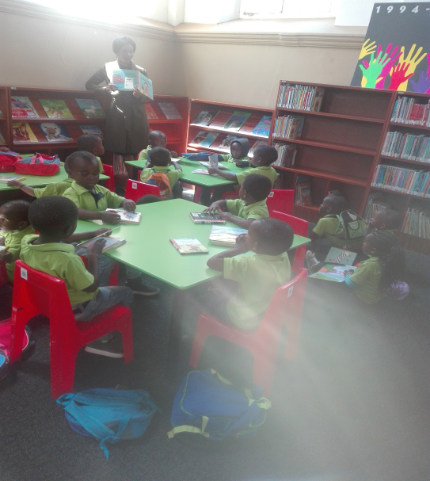

Above picture depicts Sicelimpumelelo Crèche, from Tholakele Area

4. Intergovernmental Networking
On the 9th November 2018 the Librarian attended the Interest Group Meeting (IGF) at Madadeni Library, Newcastle. The nature of this meeting serves as a platform of training and development for librarians. Training, guidance and support in Customer Care, library management and resolving common library issues across the Northern Region.

5. Items subsidized by the Department of Arts & Culture
The Library has received 3 computers, 2 for library system (SLIMS) and one for office use. The Department of Arts & Culture has also supplied library stationery e.g. patron barcodes, library signage, courier envelopes and document scanner, 3 barcode scanners, network cards and a printer. The Department of Arts & Culture is yet to install the internet connectivity; it was scheduled for the 21st November 2018 but yet not been installed. The library however is functioning through the use of personal data & modem due to that the library system relies on internet for connectivity, the registration of members, circulation of materials and to check availability of an item in the library.

6. Library Maintenance
The roof is leaking when it is raining, one can see the sunshine through the roof which indicates there are holes in the ceiling. The DB Board is aged and needs to be changed. There needs to be additional plugs as there is only one plug available for now. There are no sufficient lights in the library except for two unreliable lights, the library is dark. The library needs window repairs and door lockers installed immediately. This is compromising the safety and security of the library and its assets, the doors have locks with no keys which is unsafe during emergency cases. New lockers and keys needs to be installed. The library also needs security personnel in the day and night shifts due to the high volume of drug usage in the library premises and other promiscuous activities such littering and jolling in and around the library premises. The furniture has been moved from the hall into the library for safety.

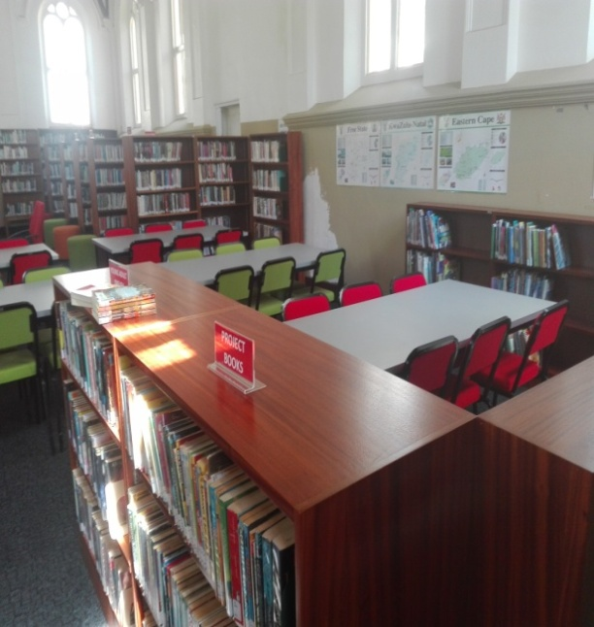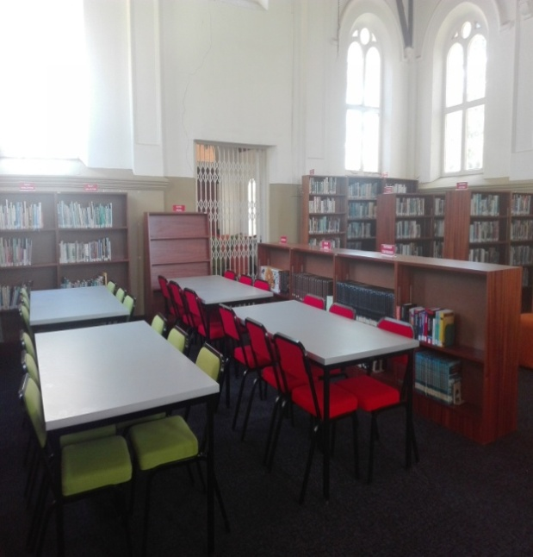
The above photos depicts the current situation at the Paulpietersburg library

7. Statistics for Paupietersburg Library

- Membership |  |  |  | Adults |  |  | Young Adults |  | Juveniles |  |  | Total
Previous month total |  |  |  | 0 |  |  | 0 |  | 0 |  |  | 0
New members |  |  |  | 5 |  |  | 6 |  | 1 |  |  | 12
Cancelled members |  |  |  | 0 |  |  | 0 |  | 0 |  |  | 0
Total carry to next month |  |  |  | 5 |  |  | 6 |  | 1 |  |  | 12
- Circulation | Adult Fiction | Adult Non-fiction | Large Print |  | Young Adult | Juvenile Fiction |  | Juvenile Non-fiction |  | Tertiary textbooks | Mags |  | Total
Afrikaans | 0 | 0 | 30 |  | 10 | 0 |  | 0 |  | 0 | 0 |  | 40
IsiZulu | 0 | 0 | 0 |  | 0 | 14 |  | 0 |  | 0 | 0 |  | 14
English | 22 | 12 | 10 |  | 8 | 2 |  | 0 |  | 0 | 0 |  | 54
Total | 22 | 12 | 40 |  | 18 | 16 |  | 0 |  | 0 | 0 |  | 108

October Library usage stats

- Membership |  |  |  | Adults |  |  | Young Adults |  | Juveniles |  |  | Total
Previous month total |  |  |  | 5 |  |  | 6 |  | 1 |  |  | 12
New members |  |  |  | 11 |  |  | 7 |  | 3 |  |  | 21
Cancelled members |  |  |  | 0 |  |  | 0 |  | 0 |  |  | 0
Total carry to next month |  |  |  | 16 |  |  | 13 |  | 4 |  |  | 33
- Circulation | Adult Fiction | Adult Non-fiction | Large Print |  | Young Adult | Juvenile Fiction |  | Juvenile Non-fiction |  | Tertiary textbooks | Mags |  | Total
Afrikaans | 20 | 0 | 43 |  | 06 | 06 |  | 00 |  | 00 | 00 |  | 75
IsiZulu | 5 | 0 | 0 |  | 00 | 02 |  | 00 |  | 00 | 00 |  | 07
English | 37 | 18 | 39 |  | 04 | 21 |  | 11 |  | 00 | 17 |  | 147
Total | 62 | 18 | 82 |  | 10 | 15 |  | 11 |  | 00 | 00 |  | 229

- Storytelling and gaming
The storytelling and gaming are social activities which are skills building especially to the young ones. These activities were conducted on the 16th and 23th August 2018 respectively to a primary school (name of school) grade 1 & grade 2. There were 30 attendees from each class. The painting is an enjoyable skill to be taught to the young ones as it a rare skill. Painting is a vocation that one can make a living out of and contribute to the economy of this country.

- Back to my roots/Azibuyele emasisweni Cultural dance
The purpose of this event is educate learners about different culture we have in South Africa special the Zulu culture since most of the learners are Zulu speaking. The event on the 19th September 2018 had 80 attendees. It was an outreach to the pre-school.

- Displays for eDumbe Library
The eDumbe library put up the display of Breast cancer awareness on the on the 01 October 2018. The purpose of the display is to make patrons to be aware of what are the causes of breast cancer and all the information about the breast cancer. Below is the picture of the display:



The eDumbe library also put up the new display on AIDS and HIV awareness on the 03 December 2018. The main aim of this display was to reminder the patrons about AIDs and HIV that it’s still kill’s people and it’s not a disease for only poor people but any 1 can get affected by Aids. As the library we put up this display to also motivate patrons to know their HIV status. Below is the display picture:

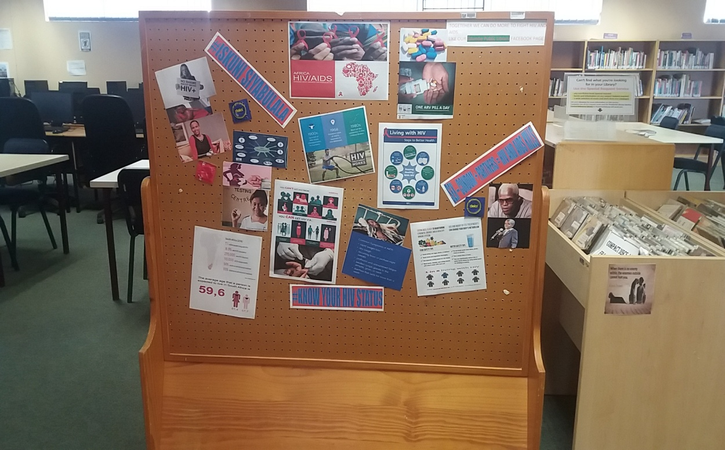

11. Heritage Day
On the 22 October 2018, Siyabonga rèche visited library to celebrate belated heritage month. A total number of 60 kids were in attendance and they were dancing and singing Zulu songs. We also have continuously basic computer classes of +30 learners who attend from Monday to Friday at 7h30 to 14h30. Below is the picture of kids singing and dancing:

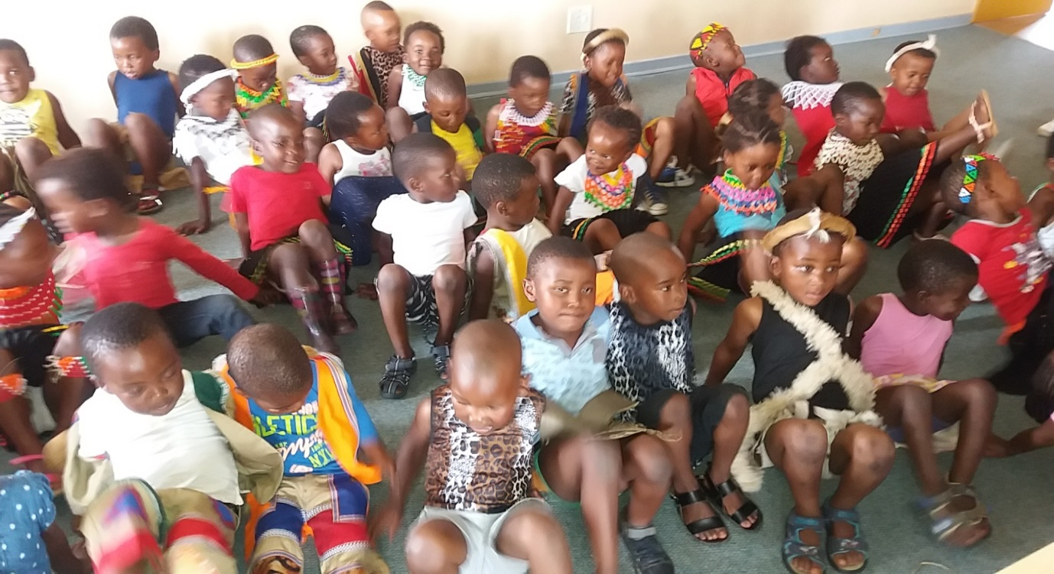
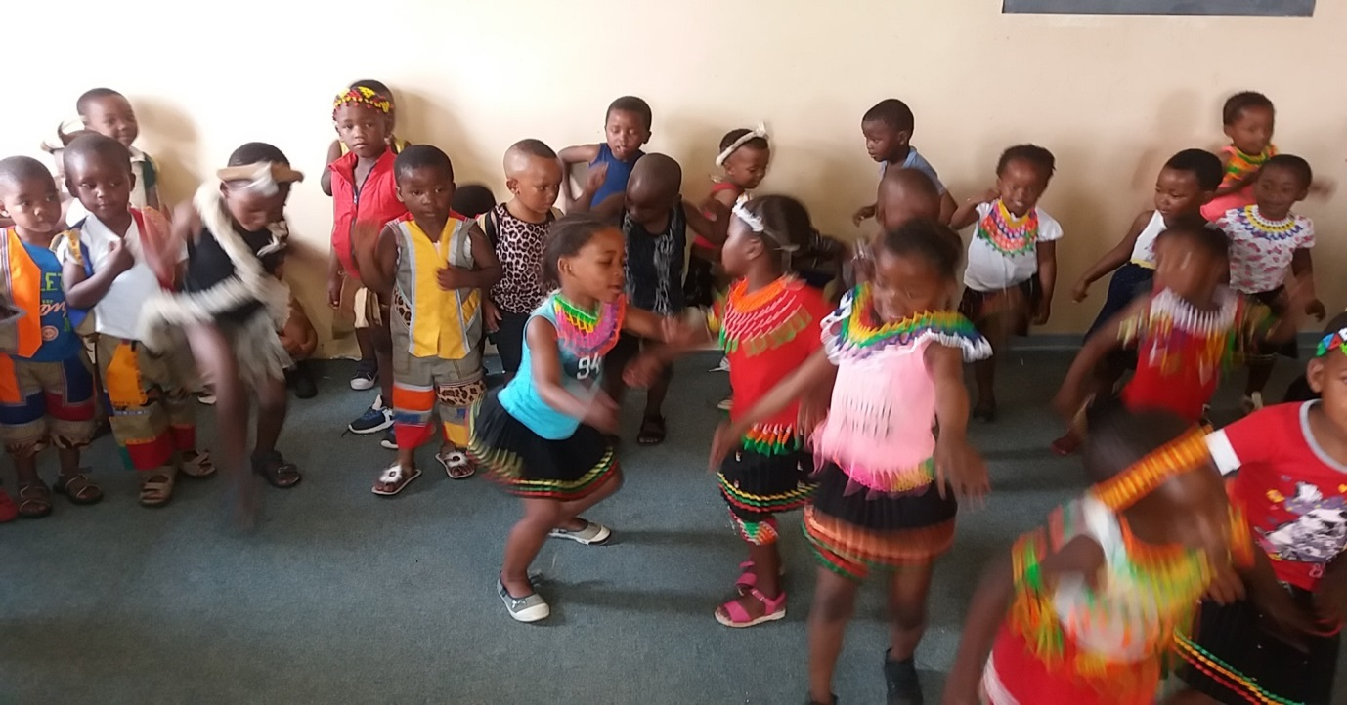
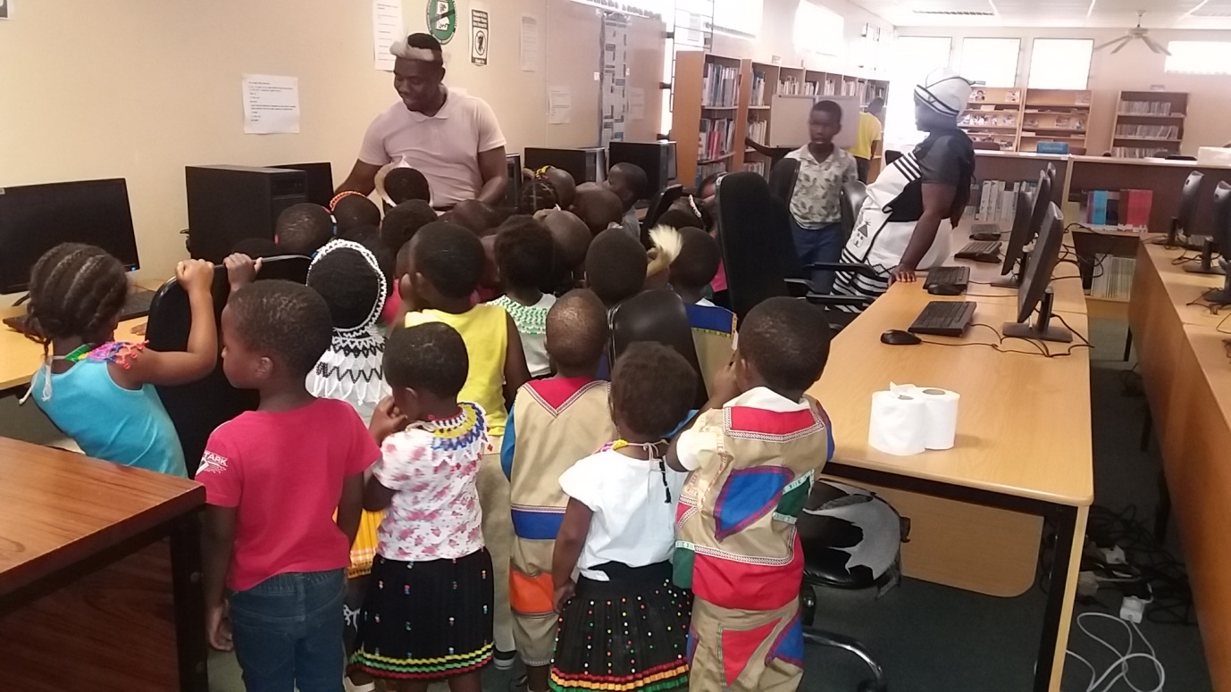
In the picture above, the librarian was showing the kids how computer operates.

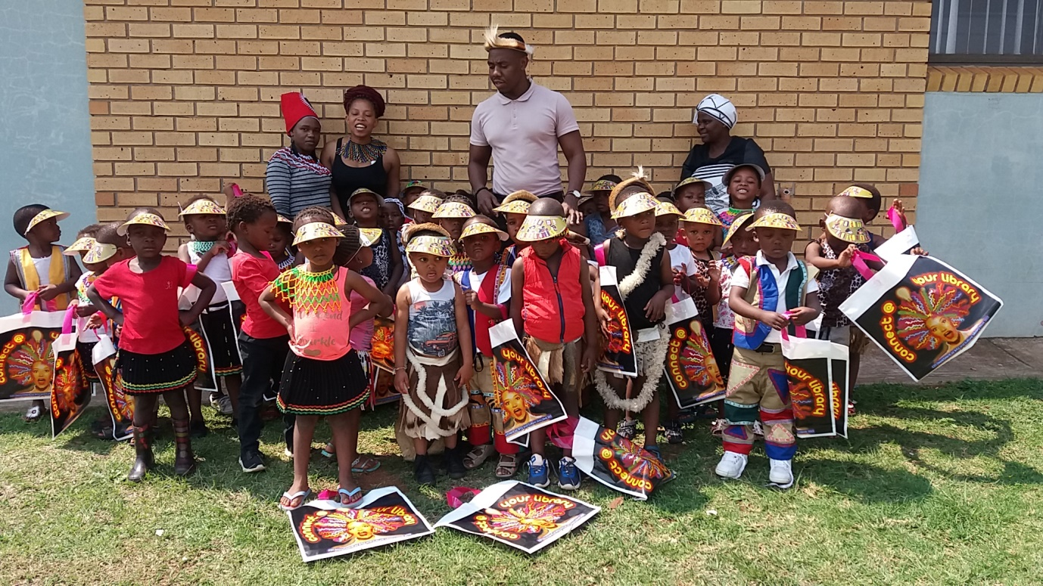
In the above picture, kids were given gifts as token of appreciation

12. CHALLENGES
As much as these two libraries are operational but there are still challenges. The eDumbe Library in particular, needs renovations, the roof is leaking, and the interior wall need to be painted and the lights are not working properly. The eDumbe library has challenges when it comes to the transport to do school visit. The Siyabonga rèche had the problem to come visit the library on heritage month (September) but there were able to come on the 22 October 2018. Furthermore Paulpietersburg Library was not operating towards the end of June 2018 however opened after appointment of the librarian resumed duties on the 1st October 2018. The library has been under renovations however; the library is not renovated properly. The roof is still leaking, there are cracks on the wall, the wall is not painted and the lights are not working properly. The DB Board needs to be changed, as it has aged with time and is very dangerous in a state it’s in. The request to change the DB Board has been lodged with the Technical Services.

- CONCLUSION
The two libraries are able to reach out to the community and engage the community, and also able to take its services to the community irrespective of challenges encountered by the libraries during planning.

D2: WASTE MANAGEMENT
The main two objectives of this section is
- To ensure Municipal Financial sustainability while rendering basic services to the community; and
- To keep environment clean for the safety of municipal citizens

- WASTE COLLECTION
Provision of waste collection services in two wards namely, ward 3 (éDumbe location and Paulpietersburg residents ) and ward 4 (Bilanyoni). Waste is collected on schedule days, In Paulpietersburg and éDumbe location its Monday and Tuesday. The Paulpietersburg town is serviced on Monday to Friday .The Bilanyoni is serviced twice a week on the following days on Wednesday and Thursday .The waste is not collected on public holiday, if it happens that your day falls on the week end you forfeit that day.
The Municipality provides receptacles in form of plastic bags; the plastic bags are placed along the streets. These receptacles are provided at no cost,they are collected at the Municipal offices . Each household is given a pack with 10 plastics full per month. The waste collection team collects these plastics, approximately two per household and then dispose at the disposal site. Waste is buried on site at least once a month with the Municipal TLB. The site has recyclers, reclaiming waste on site informal. During the holidays, the Municipality allocates staff to assist to collect waste .Staff is dived into groups depending on the amount work to be done.

Schedule of days on which waste is collected are as follows:
Days of the week | Area | Responsible Person
Monday | eDumbe location | Environmental Officer ;Supervisor
Tuesday | eDumbe location ,Bilanyoni and CBD | Environmental Officer ;Supervisor
Wednesday | eDumbe location Bilanyoni and CBD | Environmental Officer ;Supervisor
Thursday | Bilanyoni ,eDumbe location and CBD | Environmental Officer ;Supervisor
Friday | CBD | Environmental Officer ;Supervisor and Parks

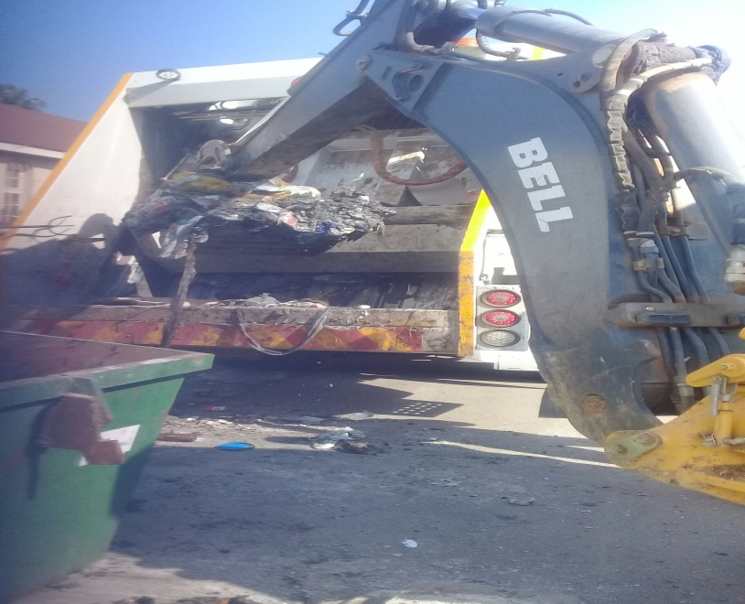
The above picture shows skip emptied by the TLB and the refuse is dropped into the refuse truck.

  - RESIDENTIAL WASTE
The Municipality provides receptacles in form of plastic bags. These receptacles are provided at no cost, they are collected at the Municipal offices .Each household is given a pack with 10 plastics full per month. Once the plastics are full of waste generated they are positioned at each household gate. The waste collection team collects waste using the Municipal compactor truck, which later disposed at the disposal site .

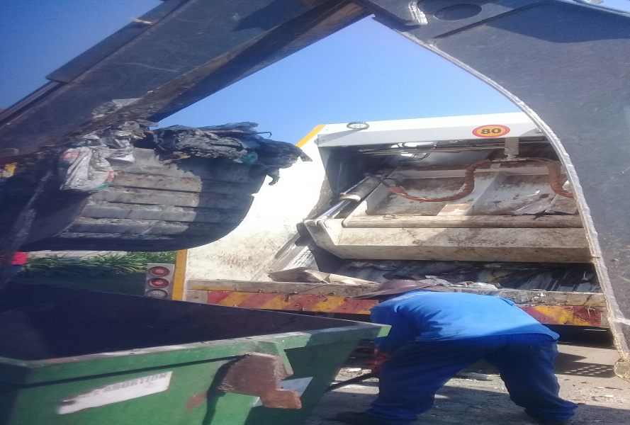
The above picture depicts the waste collection in commercial waste.

1.2 COMMERCIAL WASTE
Businesses use skips and stand bins provided by Municipality to dispose their waste. Skips are positioned at their ease. Once the skips are full of waste, they are pulled by the Municipal tractor to the disposal site to be emptied. The skips are emptied daily. Waste contained by the bins is emptied into plastic bags and positioned along the streets. The waste collection team collects waste using the Municipal compactor truck, which is later disposed at the disposal site.

2. COLLECTION FREQUENCY
The Bilanyoni is serviced twice a week on the following days on Wednesday and Thursday .The waste is not collected on public holiday, if it happens that your day falls on the public holiday you forfeit that day.

DAYS OF THE WEEK | AREA | Responsible Person
Monday | Bilanyoni ,Paulpietersburg | Supervisor & Environmental Officer
Tuesday | Paulpietersburg town ,Bilanyoni | Supervisor & Environmental Officer
Wednesday | éDumbe location ,Bilanyoni | Supervisor & Environmental Officer
Thursday | éDumbe location ,Bilanyoni | Supervisor & Environmental Officer
Friday | Paulpietersburg town | Supervisor & Environmental Officer

.

3. THE DISPOSAL SITE

Name of Disposal site | Coal siding Paulpietersburg disposal site
Site operation | The Municipality has a disposal site located approximately 2 kilometres from town. The site has a Municipal official assisting on site. The site is not an engineered. Municipality disposal site is registered with South African Waste Information Centre, where waste quantities are reported monthly. The Municipality has a waste register where all incoming vehicles are registered together with the type of waste brought on site. . The Municipality TLB buries waste twice a month. The burying of waste prolongs a life span of disposal site. In cases of fire the Municipality has a fire Department to assist.
Life span | Less than five years
Site control | The Municipality has an official, always on site even though the site is not fenced.
Type of Waste permitted | General waste

4. PARKS AND GARDENS
  - Grass Cutting
The grass cutting within the Municipality is a project, which is out-sourced to a service provider Isulami. The resources used are from the service provider. The grass cutting in Municipal parks and or premises is conducted once a month and parks cleaned weekly. The cleaning campaigns are conducted quarterly in the form of B2B programme and we have conducted one (1) campaign in ward 3 during the period under review on the 6th September 2018.

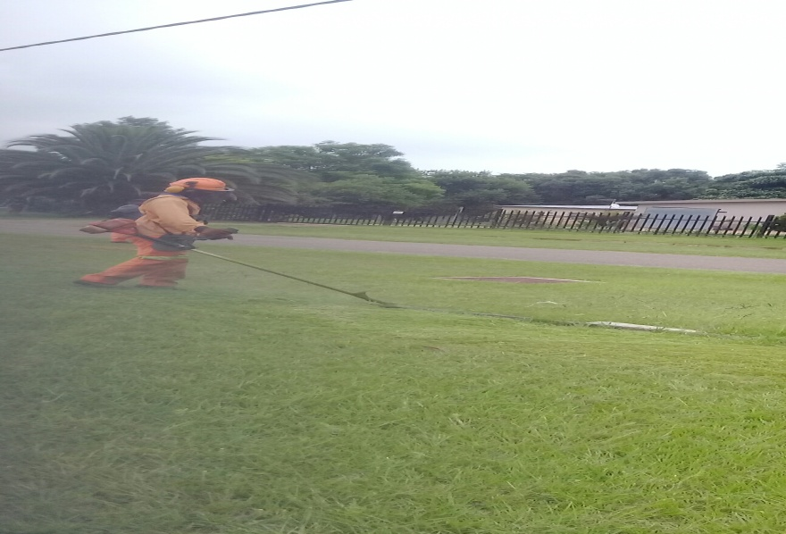


The above pictures shows the services of grass cutting by ISULAMI service provider

5. CEMETERIES SERVICES AND MAINTANANCE
The Municipality is rendering services of the above in ward 3 (Dumbe Location) & 4( Bilanyoni Township). The Municipality dig Approximately 15 graves per ward. Cleaning of cemeteries is done as and when necessary, this is done in collaboration with CWP, during cleaning we spray with the weed control chemical to prevent the growth of unnecessary grass between the graves.
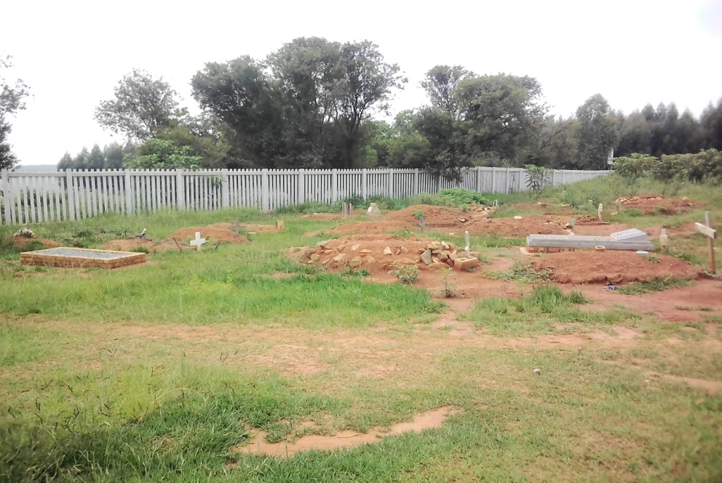

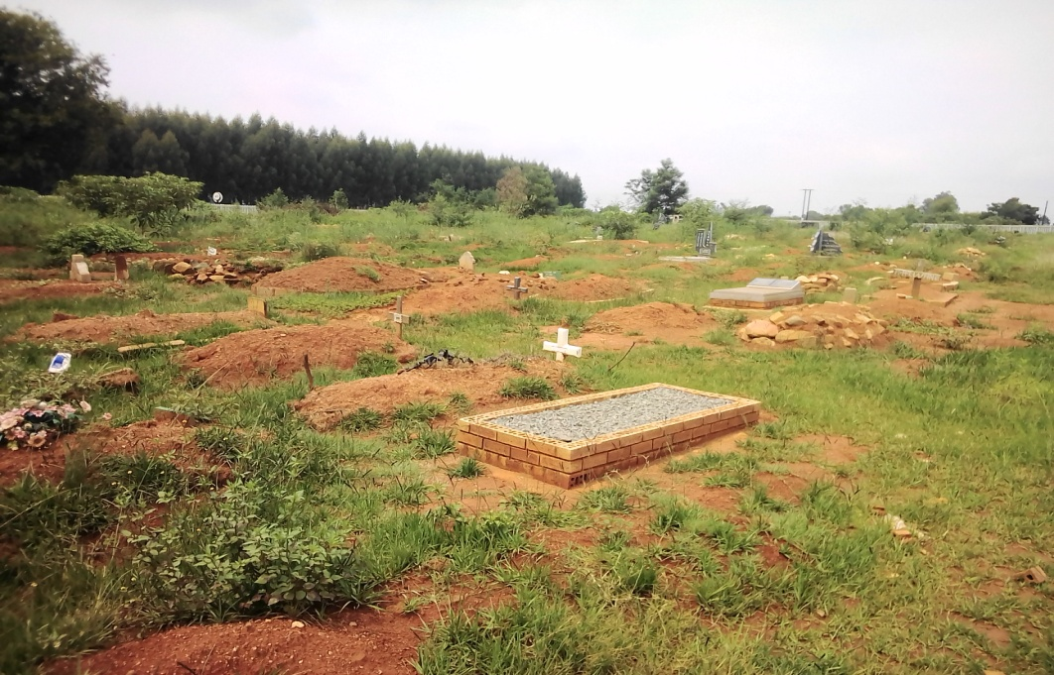
Above are the photos for the existing cemeteries which are nearing full capacity

6. ACHIEVEMENTS
- Commitment by Department of Environmental Affairs to develop an Integrated Waste Management Plan. The purpose of developing an Integrated Waste Management Plan (IWMP) is to identify existing solid waste systems, assess needs, and set ways to design, implement, and monitor a more effective and sustainable waste management program.
- Purchase of waste trucks .The municipality will also consider extending waste collection services to other areas and improve the quality of life once it become financial stable.

7. CHALLENGES

- Unlicensed disposal site.
- Lack of control of waste reclaimers on disposal sites and exposure to illegal hazardous waste disposed on disposal sites due to poor operations and management of the site.

- Mushrooming of informal housing , extension of Waste Collection to un-serviced areas

- Continuity in education and awareness programmes
- Waste collection systems within the Municipalities do not encourage at source separation and recycle.
- Environmental and health impacts associated with poor waste disposal
- Currently the Municipality is facing insufficient burial space, this is caused by the traditional burials.
- Poor management of cemeteries and parks due to insufficient personnel.
- Poor control of entrance fees to Municipal Parks especially the eDumbe Dam Park.
- Current charged tariffs for burials is not assisting the municipality for upkeep of the cemeteries.

D3: PUBLIC PARTICIPATION

BACKGROUND
Ward Committees have been established in all wards of eDumbe Local Municipality. All sectors and traditional leadership are presented in these Ward Committees. All ward committees meet on a monthly basis. However, it has been brought to our attention that some Ward Committee members passed away they need to be replaced.
There were no tangible events done in October except the sitting of ward committee meetings and community meetings in all wards. The following were activities that took place in the second quarter of the financial year:
- On the 19 November 2018 the IDP Road shows at Pinvaan hall and eDumbe Location were held where the Mayor addressed the respective communities.
- On the 26 November 2018 public team attended District Public Participation Forum at Princess Mandisa Boardroom in ZDM
- On the 07 to 10 December 2018 the public participation attended SALGA GAMES in Pietermaritzburg to assist the sport and recreation team.

All Wards with vacancies in their Ward Committees have been advised to write letters to the Office of the Speaker requesting dates for by-elections/ replacement.

PARTICIPATION IN OPERATION SUKUMA SAKHE
The participation of Ward Committees in OSS is gradually improving. Councillors normally attend OSS meetings since most of them are Chairpersons of War Rooms.

WARD COMMITTEE MEETINGS
Ward Committee meetings were held in all Wards (attendance registers available for inspection) as follows.

WARD | AUGUST | OCTOBER | NOVEMBER | DECEMBER
1 | 07/8/2018 | 17/10/2018 | 14/11/2018 | 03/12/2018
2 | 18/8/2018 | 09/10/2018 | 14/11/2018 | 05/12/2018
3 | 13/8/2018 | 17/10/2018 | 13/11/2018 | 03/12/2018
4 | 21/8/2018 | 23/10/2018 | 15/11/2018 | 06/12/2018
5 | 06/8/2018 | 16/10/2018 | 16/11/2018 | 03/12/2018
6 | 13/8/2018 | 04/10/2018 | 06/11/2018 | 05/12/2018
7 | 14/08/2018 | 15/10/2018 | 13/11/2018 | 03/12/2018
8 | 14/08/2018 | 15/10/2018 | 15/11/2018 | 06/12/2018

- Attendance registers are distributed in the meetings and signed by all members attended.
- Once signed they are handed over for verification purposes ,so as to pay the stipend.

D4: SPECIAL PROGRAMMES AND YOUTH AND SPORTS
The main objective for this portfolio is to develop Youth through Sport and Creates Institutions that will protect, upgrade and uplift Youth.
The following are the activities that took place during the period under review:

- Indigenous games were held on 18 July 2018
- Golden games held on 24 July 2018
The following took place regarding Local Mayoral Cup games:
- First Local Mayoral Cup games plenary meeting – 05 July 2018
- Meeting with Councillors – 09 July 2018
- Local Mayoral Games ward elimination – 14 July 2018 to 11/12 August 2018
- Local Mayoral Games Finals 18 August 2018 at Bilanyoni
- District Mayoral Games – 20 October 2018 in Vryheid (Abaqulusi Municipality) and there were 338 participants from eDumbe Municipality. The municipality obtain an overall position two (2) in the District.
- SALGA GAMES were held from 07 – 10 December 2018 in uMgungundlovu District Municipality in Pietermaritzburg.

All activities were successful.

D5: HIV/AIDS
The main objective for this portfolio is to ensure that all awareness campaigns are attended by all stakeholders within the municipality when there is a clarion call for their attendance. The following activities were conducted from July-September 2018
- Election of Local AIDS Council
- Election of ward AIDS Council
- Training of the above elected Council at Natal Spar, Monday, 02 September 2018- Friday, 07 September 2018

D6: SOCIAL COHESION
The objective of the municipality regarding this portfolio is to develop arts & culture and to promote talents through arts and culture. These are the activities that took place during the period under review:
- Umbele wethu
- Umkhosi womhlanga where 487 Maidens attended the ceremony and the municipality provided 23 Taxis to transport maidens and Matrons to Nyokeni, Roy Reed Dance
CHALLENGES

- Insufficient budget to cover some of the projects
- Insufficient of burial land
- Inability to attend meetings, due to unavailability of transport.

E. HUMAN RESOURCES MANAGEMENT
BACKGROUND
The field of Human Resources combines administrative personnel functions such as recruitment, employment, training and other personnel issues, with employee relations and resource planning and development. The objective is to maximize the return on investment from the human capital within the Municipality and to minimize financial risk. It is therefore the responsibility of the Human Resources Unit in consultation with Management to conduct these activities in an effective, legal, fair and consistent manner. The Human Resources Unit aimed at being an active partner in the facilitation and creation of a self-motivated and progressive Municipal workforce that is focused on Municipal service delivery objectives whilst also achieving personal and career growth as well as self-fulfilment.

- ORGANIZATION STRUCTURE:

The recruitment process used by the Municipality is a consultative and incorporated process. A request to fill a vacant position is received from the relevant Head of Department and once the Municipal Manager approves the request, the position is advertised. On receipt of applications, Human Resources do the initial sorting and summary of applicants. Employment Committee is then called to short list candidates. Once this is completed, the interview is arranged and conducted with the applicants. The interviewing panel consists of the (Municipal Manager, Departmental Directors, two councillors (if it’s senior position), Human Resources representative and the relevant Unions). During the period under review no new posts have been approved for inclusion in the organisational structure for the current financial year.

  - Positions Advertised
Positions advertised during the period under review are as follows:
- Financial Interns
- Librarian
- Creditors Officers
- Accountant Expenditure
- Supply Chain Manager
- PMS & Risk Manager
- Electrical and Mechanical Manager
- Human Resource Manager
- PMU Manager

1.2 Interviews
Interviews conducted during the period under review are as follows:
- Financial Interns
- Librarian
- Creditors Officers
- Accountant Expenditure
- Supply Chain Manager
- PMS & Risk Manager
- Electrical and Mechanical Manager
- Human Resource Manager
- PMU Manager

1.3 Recruitment and Selection

Two interns were appointed during the period under review and they are namely:

- Mr M.A. Vilakazi
- Mr L.A. Ngcobo

Furthermore the following depicted employees in the table below were appointed during this period:
INITIALS & SURNAME | POSITION | DEPARTMENT
- Mr B.W. Buthelezi | Supply Chain Manager | Budget & Treasury
- Mr N.H. Kunene | Accountant Expenditure | Budget & Treasury
- Miss X.C. Biyela | Librarian | Corporate and Community Services
- Miss L.I. Mthethwa | Creditors Officer | Budget & Treasury
- Miss N.N. Mngomezulu | Chief Financial Officer | Budget & Treasury

NB: Other positions are still outstanding as they have not been finalised by the accounting officer at the time of writing this report.

  - Fixed Term Contracts

The Municipality have appointed (43) EPWP workers that their contract will end on the 31 July 2019.

  - Staff Induction
Appointed staff is always inducted by Human Resources staff and five (5) employees were inducted.

  - Promotion

The municipality does not have promotion policy except recruitment and selection policy approved by Council.

  - Employees who Resigned/Retired/Contract Ended/Deceased & Dismissed

- Mrs S.E.P. Dlamini (Housing Manager) Retirement
- Mrs DC Dlamini – Cleaner (retirement)
- Mrs B.C. Shoba (Cleaner Supervisor) Retirement
- Mr M Nkambule – General Assistant (retirement)

2. LEAVE RECORDS

2.1. Leave Administration and Management
Municipal leave records are updated on weekly basis and also captured on the system. Municipal staff have adapted the culture of taking 16 days leave compulsory and employees ensures that the leave that the vacation leave is approved before taking it. Senior Managers also take 10 days compulsory in a cycle those who have not taken the compulsory leave Human Resource Unit has choice to forfeited them, each employee has two files one is for personnel (Particulars) documents and the other is for leave records.

2.2. Leave taken
Leave Description | Vacation  Leave | Sick leave | Family Responsibility | Study Leave | Maternity | Time Off
July | 439 | 50 | 17 | 9 | 22 | 2
August | 332 | 31 | 15 | 12 | 22 | 10
September | 181.5 | 57 | 8 | 0 | 19 | 6
October | 217 | 98 | 3 | 12 | 1 | 1
November | 137.5 | 115 | 5 | 25 | 0 | 15
December | 73.5 | 48 | 0 | 0 | 0 | 10
Total | 1380.5 | 399 | 48 | 58 | 64 | 44

2.3. Leave paid

- M. Nkambule (General Assistant)

- D.C. Dlamini (Cleaner)
- Mrs S.E.P. Dlamini (Housing Manager)
- Mrs B.C. Shoba (Cleaner Supervisor

2.4 Pro -Rata bonuses paid
- M. Nkambule
- D.C. Dlamini
- Mrs S.E.P. Dlamini (Housing Manager)
- Mrs B.C. Shoba (Cleaner Supervisor)

3. JOB PROFILES AND WAGE CURVE IMPLEMENTATION:

The Municipality did the Job Evaluation in 2015 and the outcome was implemented, the salary and wage collective agreement was implemented for 2018 to 2021.

3.1. Job description
All Municipal employees have signed job descriptions and are keep on their files

4. EMPLOYMENT EQUITY:

In compliance with the Employment Equity Act, Act 55 of 1998, the éDumbe Local Municipality appointed Mr V.B. Mbatha to developed a five year Employment Equity Plan, starting from 2019 to 2024. The progress and developments of the Employment Equity Plan are annually reported to the Department of Labour at the end of January of each year.

5. WORKPLACE SKILLS PLAN:

The Workplace Skills Plan for 2017/18 for the Municipality was finalized and delivered to LGSETA together with the Annual Training report for 2017/18 on due date, i.e. 30 April 2017 or 2018.

- TRAINING & DEVELOPMENT:

The annual training budget is centralized and managed by Human Resources, almost 5% (R550 000 grant plus council provision) of the annual training budget. The following are beneficiaries trained during the period under review:

- Mr I.M. Sibiya - Traffic Officer and have been trained for Examiner of motor vehicles (Grade A )
- Miss S.F. Ngobese – Senior Traffic Officer and been trained for Examiner of Driving Licence (Grade B)
- Cllr HH Vilakazi
- Cllr D. Mngomezulu
- Cllr Shabalala
- Cllr Hlatshwayo
- Cllr D Masondo

7. HUMAN RESOURCES POLICIES:
Through leadership from the Director: Corporate and Community Services, various Human Resources and Administrative Policies were drafted and approved by Council. The process commenced with the identification of critical areas of concern, prioritisation and selection of HR interventions and agreement on time frames for delivery. Various presentation sessions to all Departments as well as Councillors took place and the Council has already adopted the following Policies such as:

Recruitment and Selection

The following Policies have been work-shopped with Departments and are awaiting Council’s approval:

- Chronic Policy
- Code Policy
- Exit interview Policy
- Health and Safety Policy
- Leave policy
- Subsistence & Travelling policy
- Overtime policy
- Protective Clothing Policy
- Selection and Recruitment Policy
- Remuneration Policy
- Sexual Harassment Policy
- Training and Development policy
- Transfer and staff policy
- Induction policy

8. LABOUR DISPUTES AND OUTCOMES:
The purpose of a disciplinary code and procedures is to regulate standards of conduct and incapacity within an Organization. The aim of discipline is to correct unacceptable behaviour and adopt a progressive approach in the workplace.

8.1. Grievances and dismissals
Grievance procedures are available in Human Resource Unit and Municipal staff are aware of them and they are attended timeously if there is any that has been submitted but no grievances were received and no dismissal were made

8.2 Pending and finalised Municipal Cases

The Municipality has the following cases during the period under review:

Name of employee | Misconduct | Outcome
Mr L.G. Scholtz | Alleged fraud | The first Disciplinary Tribunal sat on the 16 August 2018 and was rescheduled to get witness but after the employee submitted a doctor’s note putting him on a sick leave for three (3) months (17 August to 12 November 2018) due to stress and depression. When he came back from leave the case was scheduled to seat on the 21 November 2018 prosecutor submitted sick now the matter was rescheduled again to 5 December 2018 the union representative ask for postponement the last seating was on the 19 December 2018 in the absence of the accused employee with his representative. Presiding Officer continued with the matter and ask the parties to submit the closing arguments before the 07 January 2019. Awaiting the outcome of the Presiding Officer.
Mr GE Thabethe | Arbitration | Award was in favour of the municipality and the employee remained dismissed.

9. ATTENDANCE BY EMPLOYEES AT WORK:
All departments have attendance registers, the registers are checked by Manager Human Resources on monthly basis before processing the salary of each and every employee. It is the responsibility of Supervisors to check attendance registers on daily basis, if the employee did not sign the attendance register and no leave form éDumbe Municipality applies no work no pay. During this period under review no employee was declared to have not turned up at work.

10. OVERTIME/STANDBY
During the period under review the following Standby payments were preapproved by the respective Senior Managers and the Accounting Officer
Initials & Surname | October | November | December | Totals
- H.S. Maseko | 5319.14 | 0 | 0 | 5319.14
- P.T. Dlongolo | 0 | 2476.24 | 1238.12 | 5455.37
- M.S. Nkosi | 4328.87 | 0 | 0 | 4328.87
- T.O. Mbatha | 6354.40 | 0 | 0 | 6354.40
- T.G. Msweli | 0 | 2330.58 | 2476.24 | 5677.32
- N.E. Siyaya | 0 | 9365.37 | 6243.58 | 23423.15
- S.F. Ngobese | 1235.74 | 0 | 0 | 1235.74

11. LOCAL LABOUR FORUM
No Local Labour Forum sat during this period due to unavailability of members.

12. STAFF MEETING
During this period two staff meetings were held with general staff in August 2018 and with Section Managers in October 2018.

13. GENERAL
The challenges in Human Resource section:
- Organgram not being approved after it was taken to council numerous times.
- Not being able to meet the deadline of submitting Job Description to the evaluation committee that was due on the 31 December 2018.
- Being under staff one person to deal with all Human Resource issues.
- Not being able to have the Employment Equity Plan.
- Policies not being approved by the Council.

14. CONCLUSION

In the absence of sufficient resources to address service delivery requirements, challenges will always be there in any public sector organisation and therefore this Municipality is no exception but gradually the impact to the well-being of people about what we do, will be felt no matter how small it would be to the citizens of éDumbe in its entirety. All departments have attendance registers, the registers are checked by Manager Human Resources on monthly basis before processing the salary of each and every employee. It is the responsibility of Supervisors to check attendance registers on daily basis, if the employee did not sign the attendance register and no leave form éDumbe Municipality applies no work no pay.

    - RISK MANAGEMENT

Section 62(1)I(i) of the Municipal Finance Management Act, 2003 requires that:
“The accounting officer of a municipality is responsible for managing the financial administration of the municipality, and must for this purpose take all reasonable steps to ensure –
that the municipality has and maintains effective, efficient and transparent systems –
(i) of financial and risk management and internal control”

Institutions operate in environments where factors such as technology, regulation, restructuring, changing service requirements and political influence create uncertainty. Uncertainty emanates from an inability to precisely determine the likelihood that potential events will occur and the associated outcomes.

Organisational Risk Management forms a critical part of any institution’s strategic management. It is the process whereby an institution both methodically and intuitively addresses the risk attached to their activities with the goal of achieving sustained benefit within each activity and across the portfolio of activities. ORM is therefore recognised as an integral part of sound organisational management and is being promoted internationally and in South Africa as good practice applicable to the public and private sectors.

Public sector institutions are bound by constitutional mandates to provide services in the interest of the public. No institution functions in a risk-free environment, public sector institutions also encounter risks inherent in delivering services.

The management of risk is no more or less important than the management of organisational resources and opportunities and it simply forms an integral part of the process of managing those resources and opportunities.

- Provide guidance for the accounting officer, managers and staff when overseeing or implementing the development of processes, systems and techniques for managing risk, which are appropriate to the context of the municipality.
- Advance the development and implementation of modern management practices and to support innovation throughout the Public Sector.
- Contribute to building a risk-smart workforce and environment that allows for innovation and responsible risk-taking while ensuring legitimate precautions are taken to protect the public interest, maintain public trust, and ensure due diligence.
RISK MANAGEMENT COMMITTEE:
Risk Management Committee is chaired by the Municipal manager and comprises of the MANCO members.

RISK ASSESSMENT
Management conducted organisational risk assessment whereby all possible risks were identified and listed on the risk register. The Technical Risk Management Committee then meets regularly to track progress on risk mitigation and report to the Risk Committee. The following graph indicates eDumbe Municipal top 10 risks

Risk 01 – Financial Management : Revenue
Inability to bill and collect Revenue

Risk 02 – Financial Management : Expenditure Management
Inability to pay Creditors timeously

Risk 03 – Waste Management : Refuse removal
Insufficient waste collection and failure to maintain waste site

Risk 04 – Technical Services: Electricity provision
Failure to maintain electricity network

Risk 05 – Legal Services
Lack of Municipal Protection clause in the contracts with the Suppliers and Service Providers

Risk 06 – Community Services: Cemeteries
Inability to ensure sufficient burial space and maintain cemeteries

Risk 07 – Financial Management: Budget and Reporting
Budget Issues

Risk 08 – Planning and Development : LED
Failure to create jobs

Risk 09 – Financial Management: Assets
Inability to safeguard and account for Assets
Risk 10 – Financial Management: Budget and Reporting
Failure of integrity and accuracy of financial information

  - BASIC SERVICE DELIVERY AND INFRASTRUCTURE DEVELOPMENT
Service Delivery Performance

focuses on service delivery on a service-by-service basis. It considers municipal performance derived from IDP objectives, translated into the SDBIP and presents data on Community needs and resource deployment. Some indicators are offered for some services as a basic set of key comparative data to be amassed from all relevant municipalities and other services are left for municipalities to address entirely as they consider appropriate.

The service delivery issues must be structured, captured and reflected under each priority as contained in the IDP to allow for easy comparisons on achievements against budget and The purpose of the chapter is to demonstrate to the reader, in terms of service delivery, what is being achieved and what remains outstanding. It leads to the basic questions concerning the adequacy of the efforts made by the municipality, the creativity applied and the basic standards of living that apply. There is a focus on informal settlements and the distribution of free basic services. Further information on subsidization of the poor and other benefits accruing to indigent households should also be provided. A summary of the relevant progress achieved on the relevant outcomes for local government as required by national and provincial spheres. Introductions and conclusions are left for completion by municipalities but notes are provided to identify some key issues of relevance to all communities about the way in which the municipalities are working for them. This data will also help gather a broad picture of municipal activity across the country.

Some of the material in the Annual Report format set out at Chapter 3 will not apply to all municipalities but there will be very many variations. It is, therefore, left to individual municipalities to delete aspects in Chapter 3 that is not relevant to the municipality.

Some Municipalities are using performance scorecard to manage performance of different functions. These must be aligned to the SDBIP requirements that provide a standardized mechanism to enable comparisons and benchmarking. This information must be captured in this chapter to enhance the service level information.

Infrastructure Services
The department is responsible for the provision of infrastructure development, maintenance of basic infrastructure, and service delivery to ensure sustainable services to all communities. The following sections are reporting directly to the Director for Infrastructure and Planning:
- PMU
- Electricity
- Housing
- LED and Tourism
- Roads and Storm Water/ Building and Maintenance
- IDP and Town Planning
Roads Infrastructure
Roads conditions in Paulpietersburg town, eDumbe Location and Bilanyoniand the entire wards in the municipality area of jurisdiction are bad. The Municipality does not have enough funds to address the concerns around the in eDumberoads. Roads need to be rehabilitated as they are ageing and cannot be patched anymore. MIG funds are not sufficient to cover this cost. In other ward roads are also eroded by water storms.
Municipal Buildings
The department is responsible for the planning and provision of new municipal buildings, maintenanceof various structures. To create new facilities while upgrading existing ones to be easily accessible and suitable for community needs These include pay points, libraries, community halls, municipal offices, dumping site offices, public ablutions and taxi rank, municipal houses, and other leased municipal buildings. The strategies of this department are as follows:
- Implementing programmes to upgrade existing municipal buildings and facilities
- Constructing new facilities for enhanced service delivery
- Constructing facilities closer to the communities
- Installing and implementing security measures that minimize vandalism and theft at municipal buildings.
- Raising awareness of energy saving for users of municipal buildings.
- Ensuring continuous usage of green materials for energy-saving retrofits on new and existing buildings.
- The service delivery priorities are to interact smoothly with the community and other departments without disturbance to ensure accurate implementation of planning and maintenance of municipal buildings while adhering to the National Building Regulations Act.
In the current FY the municipality is constructing two community halls in wards 1 and 6 with ablution facilities. The facility will be used by SASSA as a pension pay point and old age pensioners and physically challenged people will no longer have to travel long distances.
The below table illustrate projects being under implementation through the MIG funding:
FACILILTY | WARD | BUDGET | STATUS
KwaGedlase Community Hall | 6 | R2 850 000.00 | 30% Construction
Luneburg Community Hall | 1 | R2 850 000.00 | 45% Construction
Abaqulusi Sportsfield | 7 | R2 250 000.00 | 95% Construction
KwaNgwanyaSportsfield | 2 | R2 250 000.00 | 50% Construction
Nhlakanipho Pedestrian Bridge | 8 | R3 082 000.00 | 70% Construction
EBhishi Access Road | 5 | R2 200 000.00 | 75% Construction
eDumbe Cemetery Road | 3 | R2 200 000.00 | 0% Construction
BilanyoniSportsfield | 4 | R9 500 000.00 | 0% Construction
eBhishi Causeway | 5 | R500 000.00 | 0% Construction

Electrical Unit
eDumbe Municipality is registered electrical service provider with the Energy Regulator of South Africa (NERSA) to supply electricity to Ward 3 while the other wards (1,2,4,5,6,7and 8) are supplied and maintained by Eskom Holdings SOC Limited. Under the licence we are obliged amongst manner other things, to provide electricity in a manner which is fair, safe and within the parameters of the law. We are also obliged to also ensure that our employees work in an environment which does not affect their health and safety in a negative way.
The éDumbe Local Municipality is experiencing serious challenges with regards to the implementation of it electrification projects. The situation of éDumbe Local Municipality is not different to what most of the municipalities are doing as the project funds are only approved without the designs. The reasons for such discrepancies is caused by the lack of funding for planning costs.
The challenges faced by the municipality have compounded over the years to such an extent that each financial year a certain portion of the INEP allocation is used to fund previous financial years projects. This practice unfortunately hinders service delivery to needing communities who have longed for access to electricity, but due to previous management practices these needs were to a certain extent neglected. This has resulted in community unrest in almost all wards where electrification projects are being implemented and have stalled due to lack of funding to complete the projects.
The Council of éDumbe Local Municipality has resolved that in-order to curb the increase of debt to the INEP fund and the non-completion of INEP Projects that the allocated funding by DoE for the 2018/19 Financial Year of R 13 300 000.00 be utilised for the completion of INEP projects as well as planning for projects which would have otherwise be implemented during the same financial year had matters not been so adverse.
The below table highlights the electrification projects which are currently under construction together with the cash flow projections to completion.
There is also a challenged faced with the CoGTA Massification Grant of R 3 000 000.00 which was allocated to the municipality. After the conclusion of the designs the total project costs escalated to approximately R 8.6M thus leaving a shortfall of approximately R 5.6M of which the Council does not have.

The Summary of the INEP Grand and Budget allocation per project:
WARD | PROJECT NAME | SERVICE PROVIDER | ALLOCATION | EXPENDITURE | UNFUNDED | PROJECT STATUS | PROJECT RISK
1 | LENJANE ELECTRIFICATION | SIYATHEMBA ENGINEERS | R 3 499 054.37 | R 2 699 054.37 | R 300 000.00 | Construction at 60%. | No funding to complete project.
1 | NKONKOTHO ELECTRIFICATION | SIBGEM ENGINEERS | R 4 288 729.54 | R 4 288 729.54 | R 0 | Construction at 90% Outages to be booked. | None
1 | OBIVANE ELECTRIFICATION | SIBGEM ENGINEERS | R 0 | R 0 | R 4 104 951.61 | Designs complete. | No funding to complete project.
1 | KWASONKELA ELECTRIFICATION – DESIGNS ONLY | TBC | R 300 000.00 | R 0 | R 0 | Awaiting for service provider to be allocated. | None
2, 5, 6 | NKEMBENI ELECTRIFICATION #4 | BTMN ENGINEERS | R 2 817 755.84 | R 2 273 787.68 | R 44 230.92 | 50 of 212 connections energized. Construction at 75% for remaining scope. | No funding to complete project.
3 | INFRASTRUCTURE UPGRADE #1 | BOSTONINK ENGINEERS | R 536 256.50 | R 160 000.00 | R 0 | Construction at 90% Outages to be booked. | No funding to complete project.
3 | INFRASTRUCTURE UPGRADE #2 – DESIGNS ONLY | BOSTONINK ENGINEERS | R 1 237 166.00 | R 1 237 166.00 | R 0 | Design complete. | None
3 | PHOQUKHALO ELECTRIFICATION | SIBGEM ENGINEERS | R 0 | R 0 | R 1 500 000.00 | Project complete. | No funding to pay service provider.
6 | NTUNGWINI ELECTRIFICATION | SIBGEM ENGINEERS | R 979 037.87 | R 1 904 813.39 | R 886 172.65 | Project complete. | No funding to pay service provider.
7 | ZUNGWINI ELECTRIFICATION – DESIGNS ONLY | CIVTECH ENGINEERS | R 416 211.66 | R 416 211.66 | R 0 | Design complete. | None
TOTALS |  |  | R 14 074 211.78 | R 12 979 773.71 | R 6 835 355.18

Recommendations
- The municipality engages services providers to request them to carry the project costs to completion of all affected projects.
- The municipality continues to seek funding for the electrification program

Housing
- The Housing Act, 1997 provides for, among other things, facilitating a sustainable housing development process, and for this purpose lays down general principles applicable to housing development in all spheres of government; defines the functions of national, provincial and local government in respect of housing development; and provides for the financing of national housing programmes. Section 2 of the Housing Act, 1997 compels all three spheres of government to, among other things, give priority to the needs of the poor in respect of housing development.
- There has been a number of engagement meetings between the municipality and human settlement and finally a resolution has been reached regarding the housing projects.
Projects Ready for Stage 2 Implementation
Mangosuthu Informal Settlements Upgrade 2372 Units: To commence in the 4th Quarter (February 2019)
- the project area is in ward 2 of eDumbe Municipality and the appointed Implementing Agent is Umpheme Developments. Stage 2 application for 2372 sites to the value of R78 532 152.28 was approved by the Honourable MEC for the Department of Human Settlements and Public Works in April 2018. The project has been delayed due to outstanding technical issues that has to be resolved between Zululand District Municipality, Implementing Agent and eDumbe Local Municipality. The Department of Human Settlement is in the process of facilitating in order to ensure that all concerned stakeholders resolve outstanding matters.
- The Department of Human Settlements had to review the allocated budget for this current financial year due to the above said outstanding matters.
- Stage 2 includes site servicing and beneficiary administration however 103 site are to be serviced to an amount of R3 734 769.00 in the revised allocated budget for the current financial year. The department is the process of transferring the land to eDumbe Municipality.

Tholakele Rural Housing
- Tholakele Rural Housing Project – 1000 units: the project is in ward 5 of eDumbe Municipality and the appointed Implementing Agent is Umqondo Consultancy cc. Stage 2 application to construct 300 units (Phase 01) was approved by the Honourable MEC for the Department of Human Settlements and Public Works in November 2018.
- The Implementing Agent will commence with site establishment In February 2019.
Ophuzane Rural Housing
- Ophuzane Rural Housing Project - 1000 units: the project is in ward 8 of eDumbe Municipality and the appointed Implementing Agent is Mogeena Business.
- Stage 2 application to construct 300 units (Phase 01) was approved by the Honourable MEC for the Department of Human Settlements and Public Works in November 2018.
- The Implementing Agent will commence with site establishment In February 2019.
Projects in Stage 1
Thubelisha IRDP Project : 1000 units:
- the project is in ward 3 of eDumbe Municipality and the appointed Implementing Agent is Nazo-ke Business Management.
- The IA is currently busy with Planning Stage 1 activities and R300 000.00 is budgeted for in the current financial year.
- The Planning Stage takes close to 18 months to complete and the provision of bulk infrastructure (sanitation and Water) by the District will be key going forward.
- Project stalled due to Municipality not willing to sign Bilateral agreement.
Projects under Feasibility Studies
All the projects that are under feasibility studies are put on hold due to non-availability of SCM documents. The municipality is considering to obtain a legal opinion on the possibility to terminate these projects.

  - FINANCIAL MANAGEMENT
Section 72 (1) (a) of the MFMA outlines the requirements for mid‐year reporting.
The Accounting Officer is required by the 25th January of each year to assess the performance of the municipality during the first half of the year taking into account:
- The monthly statements referred to in section 71 of the first half of the year;
- The municipalities service delivery performance during the first half of the financial year, and the service delivery targets and performance indicators set in the Service Delivery and Budget Implementation Plan
- The past year’s annual report, and progress on resolving problems identified in the annual report; and
- The performance of every municipal entity under the sole or shared control of the municipality, taking into account reports in terms of section 88 from any such entities.
Section 54 outlines Budgetary Control and early identification of financial problems, and states that
1) On receipt of a statement or report submitted by the accounting officer of the municipality in terms of section 71 or 72, the mayor must:
- Consider the statement or report
- Check whether the municipality’s approved budget is implemented in accordance with the service delivery and budget implementation plan;
- Consider and, if necessary, make any revisions to the service delivery and budget implementation plan, provided that revisions to the service delivery targets and performance indicators in the plan may only be made with the approval of the council following approval of an adjustments budget;
- Issue any appropriate instructions to the accounting officer to ensure:
- that the budget is implemented in accordance with the service delivery and budget implementation plan; and
- that spending of funds and revenue collection proceed in accordance with the budget;
- Identify any financial problems facing the municipality, including any emerging or impending financial problems; and
- In the case of a section 72 report, submit the report to the council by 31 January of each year.
2) If the municipality faces any serious financial problems, the Mayor must:
- Promptly respond to and initiate any remedial or corrective steps proposed by the accounting officer to deal with such problems, which may include:
- steps to reduce spending when revenue is anticipated to be less than projected in the municipality’s approved budget;
- the tabling of an adjustments budget; or
- steps in terms of Chapter 13; and
- Alert the council and the MEC for local government in the province to those problems.
3) The mayor must ensure that any revisions of the service delivery and budget implementation plan are made public promptly.
Chapter 13 (135) of MFMA – which outlines Resolution of Financial Problems; states that:
- The primary responsibility to avoid, identify and resolve financial problems in a municipality rests with the municipality itself.
- A municipality must meet its financial commitments.
- ) If a municipality encounters a serious financial problem or anticipates problems in meeting its financial commitments, it must immediately:
- Seek solutions for the problem;
- Notify the MEC for local government and the MEC for finance in the province; and
- Notify organised local government

This report has been prepared in terms of the Local Government: Municipal Finance Management Act Number 56 of 2003: Municipal Budget and Reporting Regulations, Government Gazette 32141, 17 April 2009.
- MAYORS REPORT
For the mid-year budget and performance assessment, the mayor's report must also provide _
- A summary of the past year's annual report, and progress on resolving problems identified in the annual report and the audit report;
- A summary of any potential impact of the national adjustments budget and the relevant provincial
- A recommendation as to whether an adjustments budget for the municipality is necessary

  - Summary of the previous year's annual report

Whilst EDumbe has over years has been experiencing financial challenged it need to start maintaining a strong financial position through having sufficient reserves. Our reserves depleted long time as were financing long term contracts, capital and operational projects internally. The municipality is experiencing a service delivery backlogs and financial intervention is from National Treasury. Due to the rural nature of the municipality, we rely heavily on government grants as we have a low.
Consolidated Overview of the Draft Budget 2018/19
Description | Approved Budget | Actual Budget
Revenue | 154,441,934 | 152,347,458.00
Total Revenue | 154,441,934.11 | 152,347,458.00
Total Operation Expenditure | 109,922,000.00 | 118,103,938.00
Total Capital Expenditure | 41,364,800.00 | 49,823,869.00
Total Expenditure | 151,286,800.00 | 167,927,807.00
Surplus (Deficit) | 3,155,134.11 | (15,580,349.00)
The Municipality had a deficit which was caused by multi-year capital projects and existing long term contracts.

  - Financial problems or risks facing the municipality

It is a known fact that due to the nonpayment of debtors and endemic poverty in the area, the collection rate for municipal services and Rates debt recovery is low. This has a detrimental effect on the municipality’s financial resources.
Financial administration should be the second most important focus point of municipality with basic service delivery as the most important. Any additional resources should be directed at developing a financial administration turnover strategy. It must concentrate on in-service training and assistance on every aspect of financial administration with detail to the lowest level and administrative powers be delegated to the lowest level without impeding on proper internal control.

  - Remedial Action Taken on Audit Outcomes of Prior Year
EDumbe Local Municipality had received the unqualified audit report with Emphasis of matters.
The Municipality put extensive effort into implementing the recommendations in respect of prior year’s findings that were made during the previous audit. All the audit recommendations are within the Audit Action Plan where progress is regularly monitored. The Audit Action Plan form part of the 2017/18 Annual Report.
The annual report of the 2017/18 financial year is covered in a separate report to Council. Any problems and/or corrective actions identified in the oversight by Council will be monitored and action for correction in the current financial year.

  - Mid-Year Performance Assessment Municipal Adjustments Budgets
A municipality may revise an approved annual budget through an adjustments budget.
An adjustments budget—
- Must adjust the revenue and expenditure estimates downwards if there is material under-collection of revenue during the current year;
- May appropriate additional revenues that have become available over and above those anticipated in the annual budget, but only to revise or accelerate spending programs already budgeted for;
- May, within a prescribed framework, authorize unforeseeable and unavoidable expenditure recommended by the mayor of the municipality;
- May authorize the utilization of projected savings in one vote towards spending under another vote;
- May authorize the spending of funds that were unspent at the end of the past financial year where the under spending could not reasonably have been foreseen at the time to include projected roll-overs when the annual budget for the current year was approved by the council;
- May correct any errors in the annual budget; and
- May provide for any other expenditure within a prescribed framework.
“An adjustment budget may be tabled in the Municipal Council at any time after the Mid-year Budget and Performance Assessment has been tabled in the Council, but not later than 28 February of each year. Furthermore, except under certain circumstances only one adjustment budget may be tabled in Council during a financial year.”

  - Conclusion
The mid-year budget and performance assessment indicates that:

- An adjustments budget for 2018/19 will be prepared and this must be approved by Council by no later than 28 February 2019; and

- The revised SDBIP which forms the basis for the mid-year performance assessments must include adjustments necessitated by a review of the predetermined objectives and adjustments as a result of the adjustments budget, must be approved by Council,

---------------------------------------

- THE EXECUTIVE SUMMARY

The executive summary of the mid-year budget and performance assessment must, in addition to the information in executive summary of the monthly budget statement as well as on the quarterly report on the implementation of the budget and the financial affairs for the municipality provide a summary of the impact of the national adjustments budget and the relevant provincial adjustments budget.

INTRODUCTION
The Mid-Year Review has been prepared in terms of the Local Government: Municipal Budget and Reporting Regulations (as per the prescribed formats) Government Gazette 32141, 17 April 2009.

It must be noted that in all instances where the tables contained within this report include the audited outcomes for 2017/18 that these results are based on the audited annual financial statements that were audited by the Auditor General in accordance with Section 126 (3) of the Municipal Finance Management Act.

- BUDGET OVERVIEW - 2018/19 MID-TERM BUDGET PERFORMANCE

OPERATING REVENUE
It should be noted that column full year forecast should be used as guidance for adjustments except for projects and programmes that are seasonal in nature. Line managers are expected to study their expenditure trends as they have an insight at this stage considering the duration and payment schedule for such projects. Under normal circumstances, Pro-rata expenditure should be around 100% and 110% as at December 2018 and departments need to analyse all votes that are against the norm to be considered during the adjustment budget.

Monthly Budget Statement Summary
For the month of December 2018, the municipality have realised a revenue of R135,4 million this is due to the grants received, an equitable trench as well as own revenue.
Operating expenditure year to date expenditure is R53, 9 million against the budgeted expenditure of R124, 5 with a variance of R8, 3 million. The expenditure includes the amount of orders issued not processed for payment of R1, 7 million. The reconciliation has started in ensuring that service is rendered or not and follow up on the invoices

The total outstanding debtors’ amount to R126, 6 million Total amounts of creditors is R12, 2 million which included prior year accruals.
The year-to-date performance indicate that own operating revenue is below the projected revenue; and this need attention and strategies to increase our revenue base as the municipality
There is no alignment between the financial system and Schedule C and NT reports, actually the report has not been populated in full, making it hard to produce credible financial information and analysing report. The municipality needs to align all returns that are submitted to NT with Schedule C returns for compliance and credible information
The municipality is under spending when compared to their projections as per table General Expenditure. This is due to the fact that Accrual was not taken care of when the budget was approved. The Available Cash received get allocated to creditors owed first before if get distributed to the approved Budget activities.
Monthly Financial Performance by Revenue Source

The municipality have managed to collect as per below
MID-TERM REVENUE ANALYSES - DECEMBER 2018
SOURCE OF REVENUE | ORIGINAL BUDGET | MIDTERM PRORATA BUGET | Mid Year | Variance | % Variance | COMMENTS
Rates | 20,313,186 | 10,156,593 | 7,254,419 | 2,902,174 | 29% | The municipality needs to implement debt management and credit control policy to improve the collection rates
Electricity | 11,828,960 | 5,914,480 | 7,512,118 | -1,597,638 | -27%
Prepaid | 7,000,000 | 3,500,000 | 4,682,323 | -1,182,323 | -34%
Refuse | 6,074,243 | 3,037,122 | 909,439 | 2,127,682 | 70% | The nonpayment was caused by the availability of service rendered to the community affecting collection rates. The refuse trucks were only delivered this financial year
Fines | 3,803,747 | 1,901,874 | 110,020 | 1,791,853 | 94% | The budget needs to be revised. New strategies need to be introduced to improve collection
Licenses and Permits | 954,244 | 477,122 | 336,733 | 140,389 | 29%
Rental From Fixed Assets | 1,235,059 | 617,530 | 1,356,107 | -738,578 | -120%
Other | 618,000 | 309,000 | 4,457,774 | -4,148,774 | -1343% | The BTO is busy with the reconciliation to ensure that funds are receipted in the correct votes to ensure that we are not overstating our budget
TOTAL INCOME | 51,827,439 | 25,913,720 | 26,618,934 | -705,215

TOTAL REVENUE - DECEMBER 2018
Description | Budget | YTD Actual | Year TD budget | YTD variance | YTD variance | Full Year Forecast
Default [Revenue] | - | (43,864) | - | (43,864) | 0% | -
Interest, Dividend and Rent on Land | (480,000) | (523,304) | (240,000) | (283,304) | 118% | (1,046,608)
Licences or Permits | (502,536) | (206,259) | (251,268) | 45,009 | -18% | (412,518)
Operational Revenue [Revenue | (318,000) | - | (159,000) | 159,000 | -100% | -
Rental from Fixed Assets | (1,586,119) | (1,460,017) | (793,060) | (666,958) | 84% | (2,920,034)
Sales of Goods | (203,070) | (139,280) | (101,535) | (37,745) | 37% | (278,560)
Service Charges | (24,903,204) | (13,523,350) | (12,451,602) | (1,071,748) | 9% | (27,046,700)
Fines, Penalties and Forfe. | (3,828,291) | (125,610) | (1,914,146) | 1,788,536 | -93% | (251,220)
Licences or Permits | (451,709) | (210,014) | (225,855) | 15,841 | -7% | (420,028)
Property Rates | (20,313,186) | (14,044,816) | (10,156,593) | (3,888,223) | 38% | (28,089,632)
Transfers and Subsidies | (72,621,100) | (81,052,793) | (36,310,550) | (44,742,243) | 123% | (81,052,793)
CAPEX | (40,913,900) | -24,116,602 | (20,456,950) | (3,659,652) | 18% | (48,233,203)
Total Operating Revenue | (165,881,115) | (135,445,909) | (83,060,558) | 52,385,351 |  | (189,751,296)

Based on the above analysis, the collection levels are very low meaning that the municipality is depending on grant funding. Therefore the municipality needs to invest in Infrastructure Assets i.e. to priorities in Road and Electricity Infrastructure and look at other Sources of funding that may increase revenue base such as New Developments, Property Investments, Rental of Municipal Houses and revising existing lease agreements to identify if what we get is market related or not
ACTUAL VS BILLING (Collections)
DESCRIPTION | BILLING | INCOME RECEIVED | % | ESKOM PAYMENT | ELECTRICITY SALES | %
ELECTRICITY BILLING VS C | 5,538,092 | 7,138,809 | 129 | 10,540,117 | 11,821,132 | 0.89
PREPAID SALES BUDGET | 3,975,707 | 4,682,323
RATES | 14,044,817 | 7,254,419 | 52
REFUSE REMOVAL | 3,628,309 | 909,439 | 25
TOTAL | 27,186,924 | 19,984,990 |  | 10,540,117 | 11,821,132

- Our Billing system needs to improve to work reasonably well. The audit needs to take place to identify gaps, errors and areas which are not being billed. This in the process of being addressed when we start employing the Debt Management and Credit Control Policy in February 2019
- Electricity Meter readings- All queries need to be attended to and the fact that officials can’t read some meters to access control
- Credit control and debt management policy. This policy had been approved by the eDumbe Council and only needed to be promulgated into a bylaw. This would be done in the very near future.
- Indigent policy - The municipality has a policy and busy updating the indigent register and those listed would be double-checked once we have established a cheaper way of verification.
- Cleaning up of data – This project is on the pipeline. With the Compilation of Valuation Roll and Debt Management in place, it will address done.
Monthly Financial Performance by Expenditure Type
TOTAL EXPENDITURE - DECEMBER 2018
Description | Budget | YTD Actual | YearTD budget | YTD variance | YTD  Var. | Full Year Forecast
Bad Debts Written Off | 10,907,110 | - | 5,453,555 | (5,453,555) | -100% | 10,907,110
Bulk Purchases | 18,163,180 | 10,540,116 | 9,081,590 | 1,458,526 | 16% | 21,080,232
Contracted Services | 17,971,499 | 10,660,999 | 8,985,750 | 1,675,250 | 19% | 21,321,998
Depreciation and Amortisation | 7,254,300 | - | 3,627,150 | (3,627,150) | -100% | 7,254,300
Interest, Dividends and Rent on Land | 150,000 | 297,974 | 75,000 | 222,974 | 297% | 595,948
Inventory Consumed | 2,600,000 | 436,116 | 1,300,000 | (863,884) | -66% | 872,232
Operating Leases | 450,000 | 271,406 | 225,000 | 46,406 | 21% | 542,812
Operational Cost | 9,178,580 | 3,303,721 | 4,589,290 | (1,285,569) | -28% | 6,607,442
Transfer and Subsidies | 2,700,000 | 440,000 | 1,350,000 | (910,000) | -67% | 880,000
Impairment Loss | (500,000) | - | (250,000) | 250,000 | -100% | (500,000)
Remuneration of Councillors | 5,463,940 | 3,381,167 | 2,731,970 | 649,197 | 24% | 6,762,334
Employee Related Cost | 50,247,898 | 24,582,494 | 25,123,949 | (541,455) | -2% | 49,164,988
Total Revenue | 124,586,507 | 53,914,153 | 62,293,254 |  |  | 125,489,396
This monthly expenditure management ensures that funds of the Municipality are spent in terms of an approved budget and sets up controls to minimize misuse of funds through fraud and corruption and it ensures that the municipality is financially viable

Operating expenditure year to date expenditure is R53, 9 million against the budgeted expenditure of R124, 5 with a variance of R8, 3 million. Total amount of creditors is R12, 2 million which includes prior year accruals. Payments are not yet all processed within 30 days of receipt of invoice due to financial constraints

During the Assessment review it was identified that municipality has incurred unforeseeable and unavoidable expenditure recommended by the mayor of the municipality. Some errors were identified during the year. Some vote have been under/over spent due it nature. The municipality needs to reprioritise

4.5. Table C5: Monthly Budget Statement -Capital Expenditure
CAPITAL EXPENDITURE DECEMBER 2018
DESCRIPTION | Budget | YTD Actual | YearTD budget | YTD variance | YTD  Var. | Full Year Forecast
EDUMBE LINE UPGRADE | 4,300,000 | 3,913,378 | 2,150,000 | 1,763,378 | 82% | 4,300,000
ZUNGWINI ELECTRIFICATION | 4,000,000 | 4,193,580 | 2,000,000 | 2,193,580 | 110% | 4,000,000
KWASONKELA ELECTRIFICATION | 5,000,000 | 4,872,842 | 2,500,000 | 2,372,842 | 95% | 5,000,000
NHLAKANIPHO PEDESTRIAN CROS. | 2,674,000 | 1,811,820 | 1,337,000 | 474,820 | 36% | 2,674,000
eDumbe CEMETERY ROAD | 2,200,000 | 280,320 | 1,100,000 | -819,680 | -75% | 2,200,000
EBHISHI ACCESS ROAD | 1,500,000 | 761,180 | 750,000 | 11,180 | 1% | 1,500,000
KWAGEDLASE HALL | 3,000,000 | 1,182,017 | 1,500,000 | -317,983 | -21% | 3,000,000
LUNEBURG COMMUNITY HALL | 3,000,000 | 1,941,749 | 1,500,000 | 441,749 | 29% | 3,000,000
KwaNGWANYA SPORTFIELD | 3,000,000 | 1,845,720 | 1,500,000 | 345,720 | 23% | 3,000,000
ABAQULUSI SPORTFIELD | 1,500,000 | 1,776,731 | 750,000 | 1,026,731 | 137% | 1,500,000
BILANYONI SPORTFIELD | 9,500,000 | 667,266 | 4,750,000 | -4,082,734 | -86% | 9,500,000
MOTOR VEHICLES | 1,000,000 | 870,000 | 500,000 | 370,000 | 74% | 1,000,000
Laptops | 240,000 | - | 120,000 | -120,000 | -100% | 240,000
OTHER EXPENSES | 40,914,000 | 24,116,602 | 20,457,000 | 3,659,602 |  | 40,914,000
Table C5 indicates the year actual expenditure on capital expenditure for all votes of Capital expenditure amounts to R19, 3 were realized against the budgeted amount of R17, 6 million as at the end December 2018. This expenditure is in a form of infrastructure projects and motor vehicles. The municipality only budget for Laptops under furniture and equipment due to adverse cash flow. The laptops will be delivered before the end of the January 2018 and expenditure already committed.
The municipality has 5 months to ensure that projects are implemented and budget will be completed. The amount .of R9, 5 million not received to date for Bilanyoni is a concern and it must be acted on as possible
Monthly Statement Cash Flow
CFA : CASH FLOW STATEMENT ACTUALS - DECEMBER 218
Detail | Jul | Aug | Sep | Oct | Nov | Dec
Cash Receipts by Source
Property rates | 372,991 | 345,926 | 444,601 | 644,667 | 1,612,206 | 3,000,539
Property rates - penalties & collection charges | - | - | - | - | - | -
Service charges - electricity revenue | 605,820 | 1,134,195 | 921,963 | 994,508 | 676,519 | 680,389
Service charges - refuse revenue | 151,455 | 283,549 | 230,491 | 248,627 | 169,130 | 170,097
Rental of facilities and equipment | - | 25,678 | 1,355,977 | - | 25,678 | 6,419
Interest earned - external investments | 106,766 | 105,899 | 69,453 | 33,943 | 16,026 | 41,649
Fines | 27,050 | 15,970 | 12,550 | 24,650 | 18,350 | 11,450
Licences and permits | 75,856 | 76,328 | 72,876 | 74,336 | 65,580 | 52,763
Agency services | - | - | - | - | - | -
Transfer receipts - operational | 28,625,000 | 2,247,000 | 2,770,000 | 2,000,000 | 546,000 | 22,623,222
Other revenue | 969,324 | 951,052 | 827,456 | 1,067,212 | 4,744,204 | 5,920,178
Cash Receipts by Source | 30,934,262 | 5,185,597 | 6,705,367 | 5,087,943 | 7,873,693 | 32,506,706
Transfer receipts - capital | 15,000,000 | - | - | 5,000,000 | - | 8,550,000
Total Cash Receipts by Source | 45,934,262 | 5,185,597 | 6,705,367 | 10,087,943 | 7,873,693 | 41,056,706
Cash Payments by Type
Employee related costs | 2,686,800 | 5,483,538 | 4,267,000 | 2,405,135 | 2,734,461 | 3,634,279
Remuneration of councillors | 306,023 | 1,209,035 | 306,023 | 306,023 | 306,023 | 306,023
Interest paid | 5,573 | 5,306 | 5,833 | 5,553 | 5,687 | 33,435
Bulk purchases - Electricity | 2,723,187 | 8,066,202 |  | 5,984,278 | 2,507,048 | 2,741,373
Contracted services | 2,300,000 | 594,258 | 609,913 | 609,913 | 633,327 | 609,928
General expenses | 2,329,517 | 1,799,088 | 13,361,543 | 3,335,870 | 1,948,415 | 26,662,624
Cash Payments by Type | 10,351,10 | 17,157,427 | 18,550,312 | 12,646,772 | 8,134,961 | 33,987,662
Capital assets | - | 2,183,012 | - | 5,331,567 | 3,464,726 | 5,595,534
Total Cash Payments by Type | 10,351,100 | 19,340,439 | 18,550,312 | 17,978,339 | 11,599,687 | 39,583,196
Net Increase /(Decrease) in Cash Held | 35,583,12 | (14,154,84) | (11,844,94) | (7,890,39) | (3,725,994) | 1,473,510
Cash/cash equivalents at the month/year begin: | 2,794,275 | 38,377,437 | 24,222,595 | 12,377,650 | 4,487,254 | 761,260
Cash/cash equivalents at the month | 38,377,437 | 24,222,595 | 12,377,650 | 4,487,254 | 761,260 | 2,234,770

The municipality’s cash flow is still negative currently, which shows that the municipality still needs to recover its financial stability but the current status has improved as compared to the previous years; this is due to the approved cost cutting measures that the municipality is strongly applying. The second tranche of the equitable share and other conditional grants have also contributed on revenue increase. Also the monies that are not used immediately are being invested on call accounts to attract. There are no Borrowing that exist within the institution except money owed by creditors
Debtors’ ageing report
AD : AGE ANALYSIS OF DEBTORS December 2018
Detail | 0 -  30 Days | 31 -  60 Days | 61 -  90 Days | 91 -  120 Days |  | 121 -  Over year | Total  - | %
Debtors Age Analysis By Income Source
Electricity | 1,082,176 | 561,149 | (365,627) |  | 198,531 | 4,250,840 | 5,727,069
Property Rates | 1,087,561 | 928,175 | (16,167) |  | 4,891,639 | 32,679,138 | 39,570,346
Waste Management | 686,165 | 664,674 | 8,945 |  | 658,334 | 79,324,085 | 81,342,203
Other | - | - | - |  | - | 500 | 500
Total By Income Source | 2,855,902 | 2,153,998 | (372,849) |  | 5,748,504 | 116,254,53 | 126,640,19
Debtors Age Analysis By Customer Group
Organs of State | 415,244 | 471,448 | - |  | 4,029,330 | 11,201,605 | 16,117,627 | 13%
Commercial | 1,305,704 | 747,976 | (381,196) |  | 570,451 | 14,352,565 | 16,595,500 | 13%
Households | 958,069 | 763,814 | 8,347 |  | 980,212 | 85,685,707 | 88,396,148 | 70%
Other | 176,884 | 170,761 | - |  | 168,512 | 5,014,687 | 5,530,844 | 4%
Total By Customer Group | 2,855,902 | 2,153,998 | (372,849) |  | 5,748,504 | 116,254,53 | 126,640,19

The total debtor’s book continues to grow and to-date, total debtors amount to R126.6 million
An intensive collection drive aimed at ensuring that collection of outstanding debtors is improved is underway and this will be implemented during the current financial year. This process will unfold in February which will start by ensuring that debtors are encouraged to ensure that their current monthly account is settled by implementing the credit control and debt management policy. Also, a Revenue Enhancement Strategy is currently being developed it will include projects such as meter audit, customer care line, correctness of billing and will ensure that queries are attended to timorously, faulty meters are being fixed to ensure the correctness and also to avoid customer dissatisfaction. This will ensure Statements to the customers are issued on a monthly basis.
Arrears – we have lot of queries relating to customer account. The municipality needs to tackle to 100 debtors and to deal with problematic government accounts.
Customer care we need to improve on this can find a way of providing a service to customers with a ‘one-stop shop’ where all accounts could be paid to allow accounts to be paid at banks, the Post Office, retail chain stores, etc.

4. Table SC4- creditors Age Analysis

Accounts Payable Age Analysis - December 2018
Supplier | 150 Days | 120 Days | 90 Days | 60 Days | 30 Days | Current | Monthly Date of Invoice | Balance
SALGA | 2,653,842 | - | - | - | - | - | - | 2,653,842.00
ESKOM HOLDINGS SOC LIMITED) | 2,021,092 | - | - | 1,406 | 33 | 16 | 19,234 | 2,041,779.82
NGWEKAZI SECURITY | 767,915 | 236,407 | - | - | 236,407 |  | - | 1,240,729.58
SIBGEM MANAGEMENT & | 1,181,823 | - | - | - | - | - | - | 1,181,823.39
AROS PROTECTION SERVICES) | 538,554 | - | 235,886 |  | 235,886 | - | - | 1,010,327.09
ISULAMI TRADING AND | 444,215 | 137,619 | 137,619 | - | - | 41,286 | - | 760,739.07
AUDITOR GENERAL) | - | - | - | - | - | 488,465 | 157,221 | 645,685.24
BTMN ENGINEERS) | 385,498 | - | - | - | - | - | - | 385,498.16
BOSTON INK) | 376,257 | - | - | - | - | - | - | 376,256.50
INNOVATION GOVERNMENT | 325,000 | - | - | - | - |  | - | 325,000.00
SIBAYA ASPHALTING JV ZT | 303,873 | - | - | - | - | - | - | 303,872.99
MILLS FITCHET AFRICA) |  | - | - | - | - | - | 277,811 | 277,811.25
SIYATHEMBA ELECTRICAL PTY |  | - | - | - | - | - | 235,528 | 235,527.52
SHEPSTONE & WYLIE | 198,536 | - | - | - | - | - | - | 198,535.78
OTSG TECHNOLOGIES) | 172,800 | - | - | - | - | - | - | 172,800.00
DUCHARME CONSULTING) |  | - | - | - | - | 87,829 | 45,540 | 133,368.50
OTHER CREDITORS | 72,792 | - | - | - | - | 23,835 | 169,308 | 265,935
TOTALS | 9,442,197 | 374,026 | 373,506 | 1,406 | 472,326 | 641,429 | 904,641 | 12,209,531.20

Table SC4 shows the amount of Creditors ageing as at 31 December 2018.
An amount of R12, 2 million remains a liability at the end of the month; the table also shows how the municipality arrived to this amount. Even though the municipality is not paying its creditors within 30 days as required by the MFMA, the ageing of the creditors has been reduced as compared to the previous years. The 2018/19 budget did not consider the accruals since the municipality does not have any investment that is cashed backed.

It should be noted that withdrawals in terms of Section 11(1) (b) to (j) of the Local Government Municipal Finance Management Act, 2003 are prohibited and the municipality made no such withdrawals during the midterm from July 2018 to December 2018.

The following information should be noted:
Section 11(1) (b): Expenditure that was authorised in terms of Section 26(4)
- No withdrawals in terms of this section
Section 11(1) (c) Unforeseeable and unavoidable expenditures
- No withdrawals
Section 11(1) (d): Withdrawals in respect of Trust and so forth
- No withdrawals
Overpayments on monies received on behalf of a person or state body
- No withdrawals
Section 11: Withdrawals 11(1) (f): Monies erroneously deposited into bank account
- No withdrawals
Section 11 (1) (g): Guarantees, sureties and security deposits refunded
- No withdrawals

Investment Portfolio
Investment revenue is the amount of interest earned on the amount invested with various financial institutions registered with South African Banking Council. The total amount of money in the bank amounts to R39 Million as at the end of December 2018.
In line with the investment policy, funds are invested only on call accounts with FNB and Grin rod institutions. The municipality is still dealing with it financial state which does not allow us to start looking for better interest rates as cash is needed now and then and has no reserves.

Grants Income and Expenditure December 2018
EDUMBE MUNICIPALITY - GRANTS REGISTER DECEMBER 2018
GRANT | GRANT' BUDGET(DoRA) 2018 - 2019 | AMOUNT RECEIVED | YEAR-TO-DATE PAYMENTS | UNSPENT CLOSING BLANCE | % Spent | COMMENTS
Equitable Share | 66,301,000 | (49,168,131) | 35,301,000 | (13,867,131) | 53% | The amount of R62K was withheld for EPWP due to non-submission of the grant roll over application. The MIG finding of R494K is withheld due to recognition of funds; the final AFS has been submitted to NT to recoup these funds after corrections
FMG | 1,970,000 | (1,970,000) | 1,151,334 | (818,666) | 58%
Energy | 13,300,000 | (12,780,587) | 12,979,800 | 199,212 | 98%
MIG | 17,762,000 | (12,970,548) | 10,266,802 | (2,703,746) | 58%
EPWP | 1,103,000 | (835,756) | 454,452 | (381,303) | 41%
Art & Culture | 2,770,000 | (3,204,004) | 671,385 | (2,532,619) | 24% | The amount include R434k from previous year
Bilanyoni Sport field - NT | 9,500,000 | - | - | - | 0% | The amount is erroneously included in the MIG funding of R17, 7. The matter has been escalated to CoGTA, Sports Dep., PT and NT
Bilanyoni Sport field - PT | 4,500,000 | (2,250,000) | - | (2,250,000) | 0% | This is a top up to the R9.5 Bilanyoni Sport field and has been transferred in this current year. The budget need to be adjusted to include
Sports and Recreation | 89,000 | (50,000) | 8,000 | (42,000) |  | To be adjusted downward. The allocation has been revised down wards to R50k
Zoning of Land | - | (50,000) | - | (50,000) |  | To be included in the Adj. Budget
Spatial Development Fram. | 1,000,000 | (1,000,000) | 823,975 | (176,025) | 82% | To be included in the Adj. Budget
COGTA Informal Trading Stalls | 2,000,000 | (2,000,000) | - | (2,000,000) |  | The specification will be submitted before the end of January and Awarded by February 2019. Should be included in the Adj. Budget
AMOUNT RECEIVED | 53,994,000 | (37,110,895) | 26,355,748 | (10,755,147)

FUNDS RECEIVED IN THE PREVIOUS YEAR
GRANT | GRANT' BUDGET(DoRA) 2018 - 2019 | OPENING BALANCES | YEAR-TO-DATE PAYMENTS | UNSPENT CLOSING BLANCE | % Spent | COMMENTS
COGTA Elec..: Mbizeni | - | (18,361) | - | (18,361) | 0%
COGTA IDP Grant | - | (5,000) |  | (5,000) | 0%
COGTA Wall to Wall | - | (629,936) | 317,400 | (312,536) | 50%
COGTA Electrification | - | (3,000,000) | 1,945,336 | (1,054,664) | 65%
EPWP | - | (62,756) | - | - | 0% | Withheld
COGTA Refuse Truck | - | (3,000,000) | 3,314,049 | - | 110% | The grant has been used and completed. The amount of R314,048.50 was funded internally
 | - | (6,716,052) | 5,576,785 | (1,390,560)

The transfers recognised relates to grants and subsidies received. Operational and Capital Grants recognised. The municipality received a further allocation of R6, 5 million during the midterm an amount of R4, 5m and R2, 0 from Sport and Recreation Department and CoGTA respectively. The amount of R9, 5 which is erroneously included to MIG need attention administratively and political. The communication from the relevant transferring department is taking place to ensure that funds are received as this will affect our budget negatively
Grant Expenditure
It should be noted that some of the operational grants have low percentage in terms of their spending; this due to the nature of the grant and some expenditures will be reflected in the following months once they are included in the approved budget
Table SC8Councillor and Staff benefits
DESCRIPTION | June | July | August | September | October | November | December
Salary | 2,288,413 | 2,285,442 | 2,461,887 | 2,537,844 | 2,578,784 | 2,610,951 | 14,763,319
Councillor Allowance | 306,023 | 306,023 | 306,023 | 306,023 | 306,023 | 306,023 | 1,836,137
Cell phone Allowance | 50,324 | 50,324 | 50,324 | 50,324 | 54,224 | 53,224 | 308,744
Acting Allowance | 75,827 | 93,943 | 93,943 | 51,636 | 51,636 | 71,020 | 438,004
Standby Allowance | 4,037 | 7,568 |  | 27,664 | 14,172 | 9,958 | 63,399
Housing | 34,077 | 34,077 | 34,434 | 41,434 | 51,202 | 51,202 | 246,425
Travel 80% | 258,486 | 258,486 | 258,486 | 246,815 | 259,815 | 253,315 | 1,535,405
Annual Bonus | 147,088 | 366,313 | 224,226 | 218,256 | 464,359 | 72,055 | 1,492,297
Unpaid |  |  |  | - | -21,056 | - | -21,056
Leave Sold | 8,611 | 11,658 |  | - | - | 42,232 | 62,501
Back Pay | 18,060 |  | 323,804 | 25,584 | - | 113,683 | 481,131
Long service |  |  |  | - |  | 17,931 | 17,931
Responsible Person | 3,500 | 3,500 | 3,500 | 3,500 | 3,500 | 3,500 | 21,000
Pension Portion | 16,104 | 16,104 | 16,104 | 16,104 | 16,104 | 16,104 | 96,626
Reimbursement | 320,226 | 177,075 | 34,993 | - | 2,426 | 2,041 | 536,761
Medical Aid Allowance | 10,461 | 10,461 | 10,461 | 10,461 | 10,461 | 10,461 | 62,764
4% Remote Allowance | 5,756 | 5,756 | 5,756 | 5,756 | 5,756 | 13,410 | 42,191
Motor vehicles |  |  |  | 11,671 | 27,951 | 27,951 | 67,573
REFUND |  | 8,308 |  |  | - |  | 8,308
Reimbursement KM |  |  |  |  |  | 194,241 | 194,241
UIF CC | 19,011 | 19,105 | 20,050 | 19,797 | 20,096 | 19,770 | 117,828
SDL CC | 31,917 | 34,204 | 37,408 | 34,989 | 37,492 | 36,221 | 212,230
Pension CC | 138,575 | 138,004 | 145,119 | 145,333 | 145,361 | 146,990 | 859,381
SUNDRY |  | 285 |  |  |  |  | 285
NJMPF Provident CC | 253,051 | 253,352 | 272,396 | 286,519 | 286,799 | 287,643 | 1,639,760
Medical Aid CC | 150,297 | 151,515 | 150,809 |  | 157,015 | 151,849 | 761,486
Bargaining Council CC | 1,383 | 1,374 | 1,356 | 1,243 | 1,234 | 1,234 | 7,823
TOTAL | 4,141,226 | 4,232,876 | 4,451,078 | 4,040,952 | 4,473,354 | 4,513,008 | 25,852,494

In terms of section 66 of the Municipal Finance Management Act number 56 of 2003, the Accounting Officer of a Municipality must report to the council on all expenditure incurred by the municipality on staff salaries, allowances and benefit.

Employee related costs
The expenditure to date for employee related costs amounts to R24, 5 million against the expected expenditure of R25, 6 million. This is still within. For the breakdown of the employee related costs please refer to table SC8

Remuneration of Councillors
The expenditure to date for remuneration of Councillors amounts to R3, 3 Million against the expected budget of 2, 7 million. The variance is caused by the travel cost that has been paid out which exceeds the amount budgeted for

CHALLENGES: IN YEAR MONITORING (IYM)
- The in year reporting (IYM) or Schedule C template is not adhered to nor completed; only returns are submitted to treasury. We are still using the manual format when submitting our report
- Lack of review by senior managers on submissions made to Provincial Treasury;
- Cash flow projections for the municipality are prepared on the straight line basis, therefore not realistic;
- The creditors reports which is AC of appendix B and Schedule C report submitted are often not aligned;
- Municipal commitments are also understated as the municipal orders are not all disclosed, therefore the contracts register and commitments register not updated monthly;
- The municipal under spending is also due to bid committees not sitting and appointment of bid committees;
- The municipality not submitting the narrative document and therefore not complying with Municipal Budgeting and Reporting Regulations (MBRR).

- 2016/17 MID-TERM BUDGET PERFORMANCE: RECOMMENDATIONS

- The In Year Reporting (IYR) which is schedule C must be submitted on a monthly basis and report be submitted to all portfolio using the format not the manual format
- More effort should be put in reviewing the IYM submission made to PT;
- The municipality is advised to revise cash flows to align with municipal procurement plans;
- The municipality must at all times align AC of appendix B and Schedule C reports;
- The municipality needs to state names of the top 10 creditors. However, the municipality is commended for paying is creditors within 30 days;
- Municipality must update the contracts register and commitments register on monthly basis;
- The municipality is advised to have a schedule of meeting for all bid committees and honor the dates;
- The opening cash flow balance at the beginning of the month must always be captured in the CFA return; and
- The municipality is urged to adhere to submission dates and times and to submit credible reviewed work.

BUDGET PERFOMANCE vs. ADJUSTMENT BUDGET

Factors that informs the need for adjustment of the budget
Having considered the financial performance for the half year period, the following factors informed the need for the adjustment
- Under collection on own revenue
- Recognition of grants and income that were not budgeted for during the approved 2018/2019 final budget
- Withheld funds affecting equitable share downward by R465,000
- Grants budgeted but there was no written commitment from the relevant department nor included in the Division of revenue act as a results no funds were received from the Department such as Bilanyoni sport field grant for R9,500,000
- Unbudgeted capital project that are in progress that need the more funds
- Over/under spending on general expenditure

2019-20 BUDGET FOCUS AREAS

The local government equitable share will grow at an average annual rate of above 9 per cent over the MTEF, this is as a result of funds that will be added in 2019/20 and 2021/22 to offset the cost pressures of electricity purchases which continue to grow faster than inflation;
The ability of customers to pay for services is declining and this means that less revenue will be collected. Therefore we must consider the following when compiling their 2019/20 MTREF budgets:
- Cost Containment Measures are effected and that non-core items as outlined in Circular 82 are kept at a ceiling or reduced;
- Improving the effectiveness of revenue management processes and procedures;
- Ensure locative efficiency and the protection of core service delivery items; and
- The affordability of providing free basic services to all households.

- SCM ISSUES
Irregular expenditure
The Municipality reported, through the SCM policy implementation report, an irregular expenditure are yet to be investigated and recovered by the municipality. The irregular expenditure is caused, inter alia, by non-compliance to the PPPFA and SCM regulations.
It is therefore recommended that:
- Compliance to the relevant legislations and regulations is always adhered to in order to minimize and stop the irregular expenditure.
- Recovery of irregular expenditure.
SCM Reg. 36 Deviations from normal procurement processes
The municipality reported a very minimum number of procurement done through SCM Reg. 36. The municipality is applauded for keeping a very minimum number of procurement done through regulation 36.
Compliance issues
- Website information
The website of the municipality does not show up to date bid information as required in terms of Supply Chain Management Regulations. For example the advertisement of all bid invitation, Bid received register & awarded bids.
It is recommended that all the required information be published on the website so as to achieve the transparency of the procurement system and fairness as envisaged by the MFMA and SCM policy of the municipality.
- Other matters
- Model SCM Policy for infrastructure (MFMA circular 77)
- Procurement Plan vs. SDBIP & IDP
- Centralised supplier database (CSD) and adverting of tender as per MFMA circular 83 of

Quarter report is attached

- ANNUAL REPORT FOR 2016/17
AUDIT OUTCOME
The financial statements were submitted on time and Final audit Outcome is Unqualified with emphasis of matters.
- Irregular Expenditure
- Unauthorised Expenditure
- Fruitless and wasteful expenditure
- Commitments understated

BTO ASSESSMENT
The functionality of the BTO within our municipality has such challenges:
- Approval of the Organogram and Filling of vacant post on the organogram especially the Asset Management Unit
- No aligned reporting process
- No Chief Financial Officer 8 months
- Lack of implementation of internal controls (Weak internal controls) and accountability
- No capacitating of staff
- Dependency on consultants
- Subordinates are not supervised as reports are submitted to outside stakeholders without the knowledge of supervisors;
- The intervention through internal audit, when doing their audit charter is critical to BTO, so as to ensure implementation of the recommendations raised in this report

NO. | CHALLENGES / PROGRAMMES IDENTIFIED | PROGRESS ON RESOLVING PROBLEMS
1. | The municipality does not collect revenue to its maximum level | The municipality is facing serious backblocks especially with the roads infrastructure and maintenance thereafter.  The municipality must develop and adopt Revenue Enhancement Strategy  There has been a slight improvement for revenue collection. In order to effectively implement this strategy we need more funding for installation of meters  We need to maintain credible Indigent register to identify qualifying indigent consumers for free basic services and ensure that we don’t increase our debt book with consumers who are indigent
2. | Non Payment of Service providers and Inadequate Spending Against Capital Budget. | The municipality is looking at other source of financial modeling to speed up the implementation of projects and to strengthen the municipal cash flows. Several tenders have been advertised for Source of funding  The municipality has multi projects that have not been completed affecting the service delivery and this should be addressed in the next two years once as our financial situation is improving
3. | Grants Expenditure not in line with DORA requirements. | The normally affects and reduces grant allocation for outer year.  The municipality to fast-track and accelerate projects and to utilise entire funding as allocated to avoid holding of funds by NT
4. | Inadequate funding for Repairs and Maintenance. The budget does not provide enough funding to meet the demand of repairing existing water infrastructure asset. | Funding should be made available for the Development of Asset Maintenance and Replacement plan. This will assist the municipality to budget accordingly to meet the challenges faced for un-maintained infrastructure assets
5. | Multi Year projects not completed on time and poor contract management | The issue of work in progress remain a challenge even the audit has vast of issues raised for projects not completed on time, non-performing Service Providers (SP’s) not charged penalties and extension of Contract now and then  The projects which are under construction to be completed within time frames and be capitalised; and non performing SP be charged penalties  The project files be updated monthly with financial and non-financial information and this will assist in compiling credible Contract Management Register.
6. | Supply Chain Management – Non sitting of bid committees causing delay in the implementation of projects | The bid committees to adhere to the calendar for bid schedule meeting. The report for sitting of bids and implementation of procurement plans be submitted to Municipal Manager on a monthly basis
7. | Supply Chain Management – non implementation of SCM policy resulting to deviation from SCM regulations | The deviation reports are being compiled on monthly bases but no investigations have taken place as per the Municipal Public Accounting Committee
8. | Lack of Office Space | ANDM need to source funding for the construction or of municipal office space, this will ensure that service delivery is appropriately implemented and improve performance
9. | No Standard Operating Procedures (SOP’s) | The SOP’s are currently being reviewed to assist with the segregation of duties within the Budget and Treasury Office (BTO). The document should be ready for implementation by end of January 2018 and are in the stage of finalisation.
10. | Non-Implementation of audit action plan | The non-resolve issues will be included in the audit action plan and implementation is imperative to improve audit opinion from Unqualified to Clean Audit Opinion. Some of the queries were addressed during the preparation of Annual Financial Statement (AFS)
11. | Delay in implementation of Data Cleansing project due to planning | The municipality need to launch the Data Cleansing exercise ASAP. Community outreach and other source of communication will be utilised to communicate this project to all communities.  The revenue to perform reconciliation between billing system, data collected to date as well valuation roll information
12 | Non – implementation of Standard Chart of Accounts (SCOA) | The current financial system has been upgraded to be SCOA compliant. This is an ongoing process and everyone need to participate and be trained to ensure that everyone understand their requirements

- RECOMMENDATIONS

RECOMMENDATIONS ON PLANNING AND BUDGET PROCESS

- The municipality must put added effort in ensuring that all the information that is indicated as not submitted/populated in the budget check list is fully submitted and or populated to achieve full compliance;
- The municipality's grant budget must be captured as per DoRA and gazette Provincial allocations;
- The executive summary must encompass all the critical components of the budget;
- Clear and sufficient information on measurable performance objectives and indicators must be included in the budget report;
- An explanation on movements that are above or below the norm must be provided in the municipality's budget report;
- An allocation towards repairs and maintenance budget must be increased;
- The MTREF budget and IDP has to be fully aligned and SA tables A4 to A6 must be fully populated;
- The municipality must state clear and measurable objectives and also populate Table SA7;
- The must be clear information on how the municipality's SDF, IDP priorities, SDBIP and budget are aligned;
- Previous years' figures must be submitted to the LG-database; and the municipality must ensure at all times when preparing its budget that it is fully funded budget and realistic in accordance with Circular 28.

RECOMMENDED for THE BUDGET ADJUSTMENT THAT:
- The Mid-year Budget and Performance Assessment Report of eDumbe Municipality for the period ended 31 December 2018 as referred to in S72 of the MFMA be and are hereby NOTED.
- The Monthly Budget Statement for the month of December 2018 and the supporting documents as referred to in S71 of the MFMA be and is hereby NOTED.
- The Quarterly Budget Implementation Report and supporting documents as referred to in S52 (d) of the MFMA be and is hereby NOTED.
- The Consolidated Report of withdrawals from municipal bank account be and is hereby NOTED.
- The Mid-Year Budget and Performance Assessment 2018-2019 be submitted to the Provincial and National Treasury in both electronic and hard copies.
- The revision to the Service Delivery and Budget Implementation plan as referred to in S54(c) of the MFMA be and is hereby APPROVED.
- The service delivery targets and performance indicators in the SDBIP will only be approved by Council following the approval of the adjustment budget.
- The financial problems facing the municipality including any pending financial problems be and is hereby NOTED.
- Instructions as referred to in S54(d)(i) of the MFMA be and is hereby given to the Municipal Manager to ensure that the budget is implemented in accordance with the service delivery and budget implementation plan be NOTED.
- Instructions as referred to in S54 (d) (ii) of the MFMA be and hereby given to the Municipal Manager that spending of funds and revenue collection proceed in accordance with the budget be NOTED.
- The municipality as referred to in S54(2)(a) of the MFMA be and is hereby committing to:-
- Introduce steps spending since revenue anticipated is less than the projected in the municipality’s approved budget;
- Steps in terms of section Chapter 13 of MFMA is and hereby NOTED;
- The MEC for the Department of Co-operative Governance and Traditional affairs as referred to in S54 (2) (b) of the MFMA be and is hereby alerted to the financial problems facing EDumbe Local Municipality

MID-YEAR PERFORMANCE IN SUPPLY CHAIN MANAGEMENT

Introduction
Chapter 11 of the MFMA prescribes that municipalities must have and maintain a supply chain management system that is fair, equitable, transparent, competitive and cost-effective.
PURPOSE
The purpose of this report is to allow the council of éDumbe municipality to maintain oversight over the implementation of its supply chain management policy.

- MORE THAN R100 000 AWARDS
In terms of MFMA guide, the accounting officer submit a monthly report to Provincial treasury for all tenders or quotations awarded which are more than R100 000 inclusive of VAT.
List of Suppliers
In the 2nd quarter we only had Vendor on Over R100 000.00 award:
- Ukabanhle
- Kambula Electricals
- Khuphukani Electricals

- COMPETITIVE BIDDING PROCESS STILL IN THE SCM PROCESS
Contract Number | Project Name | Status
EDUMT03/2018/19 | Construction Of Edumbe Cemetery Road | BAC
EDUMT10/2018/19 | Construction Of Bilanyoni Sportfield | BAC
EDUMT17/2018/19 | Multifunctional Copier Machines: 36-month lease | BAC
EDUMT18/2018/19 | Electricity Vending Services: 3 years | BAC
EDUMT19/2018/19 | Short term Insurance: 36-month contract | BAC
EDUMT20/2018/19 | Panel of LG Seta Training Service Providers: 36-month contract | BAC
EDUMT21/2018/19 | Fixed Asset Management Consultants on a 36-month contract | BEC
EDUMT23/2018/19 | Panel of Advertising Agents: 36-month contract | BEC
EDUMT24/2018/19 | Panel of Financial Consultants: Employee Benefits Valuations, Provisions and Disclosures on 36-month contract | BEC
EDUMT25/2018/19 | Panel of Financial Consultants: AFS Support and Review on 36-month contract | BEC
EDUMT27/2018/19 | Internet Service on 36-month contract | BEC
EDUMT28/2018/19 | Supply and installation of PBX System on outright purchase | BAC
EDUMT30/2018/19 | Construction Of Ebhishi Causeway | BAC

The SCM processes for all of the tenders and bids above will be finalised by 31 January 2018.

- THE MUNICIPAL SCM REGULATION 32 APPOINTMENTS
No Regulation 32 Appointments were done in this month

- PUBLIC PRIVATE PARTNERSHIPS
The public private partnership is built through risk appointment of service providers to a panel of consultants to source funding. Every experience and qualifying bidder is being considered.

- FIXED ASSETS MANAGEMENT
Attached please see:
- ANNEXURE 7A : The Asset Register: The Extract of the Asset Register as at 30 June 2018. In the 2018/19 financial year we added two Refuse Trucks and two bakkies

- ANNEXURE 7B : An Item To Council (Disposals) : We intend to make an item to council by 31 March 2019 regarding the assets that appeared in our asset register as disposed. We are gathering the full information around this assets. We anticipate that by the end of March 2019, we will be clear on whether or not this was a disposal.

- DEVIATIONS
Attached please see:
- ANNEXURE 8A : The Deviation Register
Description | Reasons for Deviation | Supplier | Amount | Amount transferred to irregular expenditure | Amount approved by Council as valid expenditure | Amount still under investigation (Closing Balance) | Resolution No.
Tractor Repairs | Impractical to follow Official procurement processes | Anesco Toyota | R 36 417.36 |  |  | R 36 417.36
Plant Maintenance | Impractical to follow Official procurement processes | Bell Equipment | R 41 645.53 |  |  | R 41 645.53
Plant Maintenance | Impractical to follow Official procurement processes | Bell Equipment | R 29 100.64 |  |  | R 29 100.64
Councillors refreshments | Impractical to follow Official procurement processes | BL Nkwanyana | R 9 900.00 |  |  | R 9 900.00
Assets Management Services | Emergency | Ducharme Consulting | R 267 606.40 |  |  | R 267 606.40
Assets Management Services | Emergency | Ducharme Consulting | R 329 946.18 |  |  | R 329 946.18
Assets Management Services | Emergency | Ducharme Consulting | R 24 667.50 |  |  | R 24 667.50
Assets Management Services | Emergency | Ducharme Consulting | R 63 161.00 |  |  | R 63 161.00
Assets Management Services | Emergency | Ducharme Consulting | R 45 540.00 |  |  | R 45 540.00
Catering SALGA Games | Impractical to follow Official procurement processes | Duduzile Joyce Nhlengethwa | R 10 980.00 |  |  | R 10 980.00
advertising services | Impractical to follow Official procurement processes | Ilanga Newspaper | R 38 667.60 |  |  | R 38 667.60
advertising services | Impractical to follow Official procurement processes | Ilanga Newspaper | R 7 084.00 |  |  | R 7 084.00
advertising services | Impractical to follow Official procurement processes | Ilanga Newspaper | R 18 911.75 |  |  | R 18 911.75
advertising services | Impractical to follow Official procurement processes | Ilanga Newspaper | R 0.00 |  |  | R 0.00
advertising services | Impractical to follow Official procurement processes | Ilanga Newspaper | R 19 757.00 |  |  | R 19 757.00
Transformer Replacement | Emergency | Khuphukani Electrical | R 165 000.00
Electricity Poles and other damages | Emergency | Khuphukani Electrical | R 126 023.03 |  |  | R 126 023.03
Transformer Replacement | Emergency | Khuphukani Electrical | R 44 125.50 |  |  | R 44 125.50
Vehicle licensing | Impractical to follow Official procurement processes | KZN Transport Revenue | R 19 965.00
Vehicle licensing | Impractical to follow Official procurement processes | KZN Transport Revenue | R 10 776.00
Fuel and Oil | Impractical to follow Official procurement processes | Roga Motors | R 59 851.70 |  |  | R 59 851.70
Fuel and Oil | Impractical to follow Official procurement processes | Roga Motors | R 52 661.40 |  |  | R 52 661.40
Fuel and Oil | Impractical to follow Official procurement processes | Roga Motors | R 46 966.35 |  |  | R 46 966.35
Fuel and Oil | Impractical to follow Official procurement processes | Roga Motors | R 81 928.20 |  |  | R 81 928.20
Fuel and Oil | Impractical to follow Official procurement processes | Roga Motors | R 83 581.15 |  |  | R 83 581.15
Fuel and Oil | Impractical to follow Official procurement processes | Roga Motors | R 69 100.90 |  |  | R 69 100.90
Indigent burials | Emergency | Umndeni Funerals | R 5 400.00 |  |  | R 5 400.00
 |  |  |  |  |  | R 0.00
 |  |  | R 1 708 764.19 | R 0.00 | R 0.00 | R 1 513 023.19

- ANNEXURE 8B : An Item To Council (Deviation Register) The register with recorded reasons for utilising regulation 36 to appoint to seek council approval and resolutions.
- INVENTORY MANAGEMENT
In the month of December 2018, the movement in stock on hand from last month are depicted in the Stock Count Sheet and are effected in the financial system in a form of an Inventory Journal. Attached please see:
- ANNEXURE 9A : Stock Count Sheet as at 31 December 2018

- SCM POLICY UPDATE AND PROPOSED AMENDMENTS
Attached please find items of proposed amendments and updates to the SCM Policy:
- ANNEXURE 10A : An Item To Council (Amendments)
The municipality has a challenge high figures of deviation mostly due to instance where it is impractical to follow SCM processes. These sectors involve advertising, travel and accommodation, fuel and repairs and maintenance of Plant and fleet.

- ANNEXURE 10B : An Item To Council (Updates)
There are amendments we wish to make in a policy to promote and maintain practicality and efficiency of the SCM system. Some updates are expect to the policy to give effect to new regulations as per recent updates. We also wish to address weakness identified by Auditor General through 2017/18 audit.

- UNAUTHORISED, IRREGULAR OR FRUITLESS AND WASTEFUL EXPENDITURE
Attached please see:
- ANNEXURE 11A, B, C : The UIFW Register.
In the 2018/19 financial year we have recorded the attached unauthorised, irregular and fruitless and wasteful expenditure.

Table: Extract of ANNEXURE B: IRREGULAR EXPENDITURE REGISTER
DESCRIPTION | Reason for irregular | Supplier | Official Responsible | Amount (inclusive of VAT) |  | Amount transferred to debt for recovery | Amount approved by Council as valid expenditure | Amount still under investigation (Closing Balance) | Was there a need to comply with 32(6) of the MFMA(Yes/No) | Resolution No.
 |  |  |  | Current Year | Prior Years
Electrification projects | No SCM Process were followed | BTMN | Accounting Officer | R 0.00 | R 35 346 963.32 |  |  | R 35 346 963.32 | No
Security Services | Non-recommended Company Appointed | Ingonyama VIP Security | Accounting Officer | R 0.00 | R 4 771 404.80 |  |  | R 4 771 404.80 | No
Grass Cutting Services | Service of the State | Isulami Trading and Projects | SCM Manager | R 825 716.10 | R 3 116 437.90 |  |  | R 3 942 154.00 | No
Sub-Contractor | Service of the State | Linduudle (Pty)Ltd | Contract Owner | R 118 933.71 | R 0.00 |  |  | R 118 933.71 | No
KwaVova Community hall | No SCM Process were followed | Mzimkhulu | Accounting Officer |  | R 1 115 665.07 |  |  | R 1 115 665.07 | No
Clusstered sectors | Service of the State | Forest Pro | Accounting Officer |  | R 43 775.50 |  |  | R 43 775.50 | No
 | Service of the State | éDumbe PFA | Accounting Officer |  | R 11 500.68 |  |  | R 11 500.68 | No
Electricity Vending Services | Contract Expired | Syntell | Contract Owner | R 108 899.91 | R 1 186 640.12 |  |  | R 1 186 630.12 | No
 |  |  |  | R 1 053 549.72 | R 45 592 387.39 | R 0.00 | R 0.00 | R 46 645 937.11

BTMN Engineers
BTMN Engineers was appointed on the Turn-Key basis without following SCM processes. The expenditure covers electrification projects for Enkembeni phase 01 and Phase 02; KwaNgwanya Electrification and Ekhombela Electrification.

Syntel
Syntell is the service provider to electricity vending service. We had their contract having expired. There has been extensions to the contract ever since it expired. With recent legislation on contract management read with Section 116 of the MFMA extension are now allowed for up to a maximum of 6 months from that expiry date of the contract. This contract is also affected hence we have raised expenditure against this contract. The SCM processes has started and will be finalised by 31 January 2019. We recommend that the council approve this expenditure as a valid expenditure.

Isulami Trading and Projects
Isulami Trading and Projects was raised by AG as an irregular picking up DP Jele as a Director/Senior Manager of Isulami Trading and Projects. We are having a contract for grass cutting with the vendor. We are engaging the Contractor on the matter as he claim that they never had such a person in their company. We are still gathering the information to conclude the matter. The contract will expire in March 2019. We have raised irregular expenditure up to the actual expenditure to the contract. We recommend that the council take note of this expenditure and once the matter is concluded we will come back and report.

Mzimkhulu Construction
The municipality appointed Mzimkhulu Construction for the construction of KwaVova Community Hall without following supply chain processes. The reasoning provided was that Mzimkhulu Construction did good work in one of the similar project during the year .KwaVova Community Hall had initially awarded to Sizimiselelengomsebenzi and challenges were encountered which led to appointed contractor leaving the site.
Accounts Payable Transactions
Date | Reference | Code | Debit | Credit | Description
Name: MZIMKHULU TRADING ENTERPRISE
 | Opening Balance |  | 0.00
 | Period Opening Balance |  | 0.00
2015-10-28 | 1 | INMIG |  | 162 182.25 | GAMAKAZI HALL
2015-11-11 | EDUMBE MUNICIPALITY | PM | 162 182.25 |  | MIG PAYMENTS
2015-11-30 | 2 | INMIG |  | 296 001.46 | GAMAKAZI HALL
2015-11-30 | EDUMBE MUNICIPALITY | PM | 296 001.46 |  | DECEMBER PAYMENTS
2015-12-15 | 3 | INMIG |  | 499 285.62 | GAMAKAZI HALL
2015-12-15 | EDUMBE MUNICIPALITY | PM | 499 285.62 |  | MIG PAYMENTS
2016-02-04 | 4 | INMIG |  | 251 485.52 | CONSTRUCTION OF GAMAKAZI HALL
2016-02-16 | 5 | INMIG |  | 142 399.68 | CONSTRUCTION OF GAMAKAZI HALL
2016-02-19 | MZIMKHULU TRADING | PM | 251 485.52 |  | MIG PAYMENTS
2016-02-19 | EDUMBE MUNICIPALITY | PM | 142 399.68 |  | MIG PAYMENTS
2016-03-18 | 6 | INMIG |  | 213 086.96 | CONSTRUCTION OF GAMAKAZI HALL
2016-03-31 | EDUMBE MUNICIPALITY | PM | 213 086.96 |  | MZIMKHULU TRADING
2016-06-29 | INV01 | INMIG |  | 229 226.69 | KWAVOVA COMMUNITY HALL
2016-06-29 | INV02 | INMIG |  | 253 464.85 | KWAVOVA COMMUNITY HALL
2016-06-29 | INV07 | INMIG |  | 305 885.38 | GAMAKAZI HALL
2016-07-07 | EDUMBE MUNICIPALITY | PM | 305 885.38 |  | MZIMKHULU TRADING
2016-07-07 | EDUMBE MUNICIPALITY | PM | 229 226.69 |  | MZIMKHULU TRADING
2016-07-07 | EDUMBE MUNICIPALITY | PM | 253 464.85 |  | MZIMKHULU TRADING
2017-01-20 | INV 08 | INMIG |  | 298 704.37 | KWAVOVA COMMUNITY HALL
2017-01-31 | 20 | INMIG |  | 253 507.25 | CONSTRUCTION OF GAMAKAZI HALL
2017-03-17 | EDUMBE MUNICIPALITY | PM | 253 507.25 |  | MZIMKHULU TRADING
2017-03-23 | EDUMBE MUNICIPALITY | PM | 298 704.37 |  | MZIMKHULU TRADING
2017-05-17 | INV03 | INMIG |  | 204 187.45 | CONSTRUCTION OF KWAVOVA COMMUNITY HALL
2017-06-30 | 6 | INMIG |  | 130 071.71 | COMPLETION OF KWAVOVA COMMUNITY HALL
2017-06-30 | 9 | INMIG |  | 430 920.00 | CONSTRUCTION OF KWAGAMAKAZI HALL
 | Period Closing Balance |  | 969 366.61
 | Closing Balance |  | 765 179.16

Accounts Payable Transactions
Date | Reference | Code | Debit | Credit | Description
Name: SIZIMISELENGOMSEBENZI TRADING
 | Opening Balance |  | 0.00
 | Period Opening Balance |  | 0.00
2015-10-28 | 1 | INMIG |  | 365 315.96 | KWAVOVA COMMUNITY HALL
2015-11-11 | EDUMBE MUNICIPALITY | PM | 365 315.96 |  | MIG PAYMENTS
2015-11-30 | 2 | INMIG |  | 194 797.37 | KWAVOVA COMMUNITY HALL
2015-11-30 | EDUMBE MUNICIPALITY | PM | 194 797.37 |  | DECEMBER PAYMENTS
 | Period Closing Balance |  | 365 315.96
 | Closing Balance |  |  | 0.00

Ingonyama Security
éDumbe Municipality appointed Ingonyama Security to provide security and protection service for a period of 3 years. The contract or tender was advertised however the it was awarded to the bidder not recommended. In such instance MFMA Section 114 (1) had to be applied which goes "114. (1) If a tender 'other than the one recommended in the normal course of implementing the supply chain management policy a municipality or municipal entity is approved, the accounting officer of the municipality must, in writing notify the Auditor-General, the relevant provincial treasury and the National Treasury and, of the 15 reasons for deviating from such recommendation." Such procedure was not followed.

Calculation =(128540*36)+(17995.6*8)
= R 4 771 404.80

Forest Pro
éDumbe Municipality transacted with Forest Pro. Upon gathering of information that pertains to declaration of Interest. I was found that on one declaration that was made to the employer as a Councillor in his second term. Forest Pro also declared his interest in the transaction amounting to R14 034.83 as it is required by the SCM Policy
.
Accounts Payable Transactions
Supplier | Date | Reference | Code | Debit | Credit | Description
Name: FOREST PRO
 |  | Opening Balance |  | 0.00
 |  | Period Opening Balance |  | 0.00
FOR002 | 2015-04-20 | INV55984 | SINV |  | 7 190.00 | Echo chainsaw cs-6205x/4 RS &Jerrycan 5L
FOR002 | 2015-04-20 | INV56054 | SINV |  | 629.87 | Green plastic rake & Steel digging spade
FOR002 | 2015-04-20 | EDUMBE MUNICIPALITY | PM | 7 190.00 |  | APRIL 20
FOR002 | 2015-04-21 | 21040011 | CASH | 629.87 |  | FNB OB 000009161 FOREST PRO CC
FOR002 | 2015-11-04 | INV58649 | SINV |  | 1 335.82 | REPAIR FIRE UNIT ON FIRE TRUCK
FOR002 | 2016-02-02 | EDUMBE MUNICIPALITY | PM | 1 335.82 |  | FOREST PRO
FOR002 | 2016-02-04 | INV59764 | SINV |  | 552.90 | Repair : Chainsaw
FOR002 | 2016-03-09 | INV59444 | SINV |  | 14 034.83 | Bakkie Sakkie 600 Litres
FOR002 | 2016-04-04 | EDUMBE MUNICIPALITY | PM | 552.90 |  | FOREST PRO
FOR002 | 2016-04-04 | EDUMBE MUNICIPALITY | PM | 14 034.83 |  | FOREST PRO
FOR002 | 2016-04-14 | INV60862 | SINV |  | 11 527.68 | Municipality house pump
FOR002 | 2016-04-26 | INV60792 | SINV |  | 8 504.40 | Jo Jo tanks at Municipal offices
FOR002 | 2016-07-21 | EDUMBE MUNICIPALITY | PM | 8 504.40
FOR002 | 2016-10-14 | EDUMBE MUNICIPALITY | PM | 11 527.68 |  | FOREST PRO
 |  | Period Closing Balance |  | 11 527.68
 |  | Closing Balance |  |  | 0.00

Dumbe FPA
éDumbe Municipality transacted with eDumbe PFA for an amount of R11 500.68 which required declaration of interest. No declaration was submitted.
Accounts Payable Transactions
Supplier |  | Date | Reference | Code | Debit | Credit |  | Description
Name: EDUMBE FPA
 |  |  | Opening Balance |  | 0.00
 |  |  | Period Opening Balance |  | 0.00
EDU003 | 2016-04-25 |  | IN100266 | AP-BFWD |  |  | 11 500.68 |  | OPENING BALANCES
EDU003 | 2017-07-20 |  | EDUMBE MUNICIPALITY | AP-PAYM | 11 500.68
 |  |  | Period Closing Balance |  | 11 500.68
 |  |  | Closing Balance |  |  |  | 0.00

- ANNEXURE 11D: An Item To Council (Irregular Expenditure Register). We seek the approval of these expenditures as valid expenditure and /or write off of some irrecoverable expenditure.

- CONTRACT MANAGEMENT
Project Description | Contractor | Reason to amend
Fixed Assets Management | Ducharme Consulting | month-to-month basis
Copier Machine Rentals | Sesikhona | month-to-month basis
Electricity Vending Machines | Syntel | month-to-month basis
Municipal Assets Insurance | Aon South Africa | one year extension ending 30 June 2019

- PROCUREMENT PLAN

The following contracts remain to be advertised in the 2018/19 Procurement Plan
Project Name and Brief Description | Duration | Depart. | Estimated Annual Budget | Envisaged Date of Advertisement | Envisaged Closing Date of bid | Envisaged Award Date
Panel of Service Providers: Records Management | 3-year | Corporate & Community Services | R 0.00 | 21-Jan-19 | 05-Feb-19 | 15-Feb-19
Panel of Environmental Consultant : LandFill Site | 3-year | Corporate & Community Services | R 0.00 | 21-Jan-19 | 05-Feb-19 | 15-Feb-19
Panel of Financial Consultants: Forensic Audit & Investigation | 3-year | Budget and Treasury Office | R 0.00 | 21-Jan-19 | 05-Feb-19 | 15-Feb-19
Panel of Local Suppliers: Cleaning Material | 3-year | Corporate & Community Services | R 0.00 | 21-Jan-19 | 05-Feb-19 | 15-Feb-19
Panel of Local Suppliers: Personal Protective Clothing | 3-year | Planning & Infrastructure Services | R 0.00 | 21-Jan-19 | 05-Feb-19 | 15-Feb-19
Panel of Local Suppliers: Stationery and Printing | 3-year | Corporate & Community Services | R 0.00 | 21-Jan-19 | 05-Feb-19 | 15-Feb-19
Panel of Legal Services | 3-year | Corporate & Community Services | R 0.00 | 21-Jan-19 | 05-Feb-19 | 15-Feb-19
Repair of Fuel pumps | Once-off | Budget and Treasury Office | R200 000 | 21-Jan-19 | 05-Feb-19 | 15-Feb-19
Service Provider: Security and Protection Services | 3-year | Corporate & Community Services |  | 21-Jan-19 | 05-Feb-19 | 15-Feb-19
Internal Audit Services | 3-year | Executive and Council |  | 21-Jan-19 | 05-Feb-19 | 15-Feb-19
Panel of Suppliers : Fuel and Oil | 3-year | Budget and Treasury Office |  | 21-Jan-19 | 05-Feb-19 | 15-Feb-19
Service Provider: Banking Services | 5-year | Executive and Council | R 0.00 | 21-Jan-19 | 05-Feb-19 | 15-Feb-19

  - PLANNING AND DEVELOPMENT
The Planning and Development Unit primary function within the Municipality is to regulate and control all development.
- Regulation of land uses and building activities through enforcement of the Spatial Development Framework and the eDumbe Core Urban Scheme, 2014, as well as the National Building Regulations and Building Standards Act No. 103 of 1977.
- Provision of residential, business, industrial, and institutional sites to address the demand by the community
- Promotion of the correction of historically segregated spatial planning of settlements.
- Formalization of informal settlements.
- Creation of rural villages
- Formulation and enforcement of densification policy
- Encouragement of mixed land use
- Promotion of infill development
- Formulation of long term development plans

The unit is also responsible for the following sections:
- Integrated Development Planning (IDP)
- Spatial Planning
- Local Economic Development (LED)
- Tourism
- Housing/ Human Settlements
- Development Planning Shared Services (DPSS)
The Planning Unit is seen as a key role player or contributor in developing the Municipality and ensuring the Municipality is constantly progressing (future development of a shopping centre and middle-income housing. The unit has also been further assisted by the introduction of DPSS Staff.
Catalytic Projects
- Mining
- Valpre Water Plant Reopening
- Fresh Produce Market
- éDumbe Shopping Centre
- Agriculture and Forestry

Challenges within the unit
- It is proposed that the position of Building Inspector be filled at our earliest convenience.
- It is also proposed that the Land Use Inspector post be generated and be filled through excess staff
- It is also proposed that the Land Development Administrator position be filled internally to minimize number of vacant position within our Department.
- It is recommended that the maintenance of eDumbe Dam Park be administered by Tourism Intern
- It is also suggested that tariffs for eDumbe Dam Park in place as soon as possible or the facility be outsource.
- It is recommended that Erf.643 Paulpietersburg, earmarked for Middle Income Housing project be resolved to the benefit of eDumbe residents as part of service delivery.
Funded Projects
- Single Land Use Scheme (WALL TO WALL SCHEME) – R1 000 000
- Spatial Development Framework – R1 000 000K
- Informal Traders Market Stalls R2 000 000
Inhouse Projects assisted by Government Departments
- Human Settlement Sector Plan
- LED/ Tourism Sector Plan
- Integrated Transport Plan
Stuck Projects
- eDumbe Heritage Festival
- Middle Income Housing Project
- Northern Precinct Shopping Centre
- Landfill Site Project
- Land Audit (Paulpietersburg, Dumbe&Bilanyoni Township)

Spatial Planning, Scheme Enforcement and Controls
This subsection subscribes to the submission and approval of building plans mainly in the Primary Node/ Paulpietersburg in terms of the Spatial Development Framework (SDF) which is also the administrative centre of éDumbe Municipality.

However, this section lacks the expertise of the Building Control Officer as well as the Building Inspector who would inspect properties and issue transgression letter to non complying property owners. These two vacancies are catered for under the supplementary wing of Zululand Development Planning Shared Services (ZDPSS). éDumbe Municipality have entered into an agreement with the family of municipalities under Zululand district Municipality to share costs associated with town and regional planning.

The Senior Town Planner is shared between Abaqulusi LM and éDumbe LM. The sharing costs was subsequently reduced drastically in the 2018/ 19 financial year by the Municipality which will make it virtually impossible to fill the above two (2) vacancies. This shall lead to the noncompliance with the enforcement of the scheme, not only in Paulpietersburg but in eDumbe and Bilanyoni Townships respectively which are secondary nodes and proclaimed townships. The unit of Town Planning is not performing well only because it is under staffed.

Local Economic Development
- To contribute towards a better life for society by coordinating sustainable, social, and economic developmental programmes.
- To create a conducive environment for business investment and growth for job creation.
The municipality had an outdated LED strategy since 2016/17; to date, greater effort has been made to improve the situation. The final LED strategy is expected to be approved by Council in May 2019 subject to the grant funding made available.. Various stakeholders have been consulted to fund our proposal for the review of a comprehensive LED strategy for eDumbe 2025.
Challenges on LED
Through EPWP and CWP the municipality has contributed positively in maintaining a safety net for the poor communities and alleviating poverty where it matters the most. There is still a lot of work to be done for us to improve on this section. The finalization of the LED Strategy being the key factor.

SDBIP ANALYSIS – TARGETS VS ACTUAL
ANNEXURE 1

